The impact of AI on sustainability in agriculture:

computer vision in precision agriculture

Word Count:

The impact of AI on sustainability in the agricultural industry: (opportunities) and limitations.

* Subtitle? Depending on SLR: capabilities framework/opportunities
* Subtitle not necessary register in April for freedom
* Expert panel - > most important access to experts

Name:

Student number:

Supervisor:

Master thesis submitted for obtaining the degree master in commercial sciences:

Management and Informatics

Academic year: 2022 – 2023

**Table of Contents**

1 Introduction 3

1.1 Overview 3

1.2 Research Objectives 4

1.3 Research Questions and Hypotheses 4

1.3.1 Research Questions 4

1.3.2 Hypotheses 4

2 Literature 5

2.1 Agricultural sector 5

**2.1.1 The Meaning of Agriculture** 5

**2.1.2 Relevance of Agriculture in the Current and Future** 5

**2.1.3 Where We Set Boundaries in Agriculture** 6

**2.1.4 Different Types of Agriculture** 6

**2.1.5 Evolutions in the Agricultural Industry** 7

2.2 Sustainability 8

**2.2.1 Definition** 8

**2.2.2 General State of Affairs Regarding Sustainability** 8

2.2.3 Literature about Sustainability; why is it current, the current evolutions, new trends, and the future of sustain**ability 9**

**2.2.4 Sustainability in the Agricultural Sector** 10

2.3 Artificial Intelligence 11

2.4 AI and the agricultural industry 12

**2.4.1 Gaps in the Literature Review** 13

**2.4.2 Capability Approach** 14

3 Methodology 15

3.1 Motivation for the Selected Research Method 15

3.2 Selection of Organizations and Professional Respondents 15

3.3 Operationalization 16

3.4 Encoding 17

3.5 Evaluation criteria 17

4 Results 19

4.1 Qualitative results 19

4.2 Insightful Quantitative Data as Derived from the Qualitative Responses 23

4.3 Demographic results 24

5 Discussion 25

5.1 Positioning of the findings 37

5.2 Scientific contributions 37

5.3 Practical contributions 38

5.4 Research limitations 38

6 Conclusion 39

Bibliography 41

# Introduction

## 1.1 Overview

Notably, sustainability in agriculture has become more conspicuous and attracted a lot of conversation and attention in the contemporary world. This is attributed to the fact that agriculture, besides being the main food source for the tremendously growing world population, has numerous environmental and social implications. Most attention has been driven towards ensuring that the two components are not severely affected by agriculture, as technological experts focus on ensuring that the farming practices being put in place are entirely conventional. Ideally, as the world population gradually grows, the food demand also grows. According to the United Nations (2017), the global population, which in the same year was at 7.59billion, was anticipated to grow to at least 11 billion by the year 2100; such a projection in population implies that there would be much uncontrollable demand, which would consequently put pressure on the current availability of food and ability to produce sufficient food on the planet.

Intensive food production has put unimaginable pressure on the soil, which is the greatest existing challenge. Soil health and ability to produce more and more foods have deteriorated tremendously over the years as most farmers in the agribusiness field excessively use chemicals, fertilizers, and harmful pesticides or sprays. In the long run, when not properly articulated, these practices lead to an inevitable significant reduction in crop yield, thus negatively affecting the planet's ecosystem. Despite these long-term, life-threatening predicaments, Ltd (2023) suggests that the sustainable agriculture market (agribusiness) is anticipated to grow rapidly and will be more than 31.4 billion dollars by 2031.

With the growing population, as suggested by Padilla and Hudson (2019), producers have been left with no option but to farm the already exhausted limited arable lands to meet the demand and also to attain the sustainable development goals (SDGs), which have emphasized alleviation of poverty and containment of hunger by 2030 globally. As a result, the greatest global dilemma of the 21st century is how to feed the growing population while reducing adverse environmental effects and minimizing climate change. This, therefore, means that the menace surrounding agribusiness and ecology should be addressed effectively for a better tomorrow.

For the producers to ensure sustainability in agriculture, modern technology has to be incorporated, and that is where technologies such as Artificial Intelligence (AI) come into play. AI is one of the most trending areas in agriculture and is utilized today to solve challenges, notably those involving the use of the labor force, improving resource efficiency, and facilitating the growth of sustainable businesses. People are more likely to build these applications now that technology advances quickly (Kose et al., 2022). To solve the challenges in agriculture and increase productivity, various AI strategies have been proposed, including artificial neural networks, Fuzzy Logic, modern support vector machine systems, Deep Learning (DL), robotics, and the renowned K-nearest technology (Sachithra & Subhashini, 2023).

Artificial Neural Networks (ANNs) are mathematical models that mimic the structure and operation of biological brain networks. ANNs are intended to learn from the data they are given and then use that information to make adaptive, prognostic judgments. Crop production forecasting, insect control, and animal health monitoring are all accomplished in agriculture using ANNs (Sachithra & Subhashini, 2023). On the other hand, fuzzy logic, which is based on set theory and logic operations, helps handle issues using unreliable data and gives control systems the capacity to make decisions with improved reasoning skills. Fuzzy logic has been implemented in agriculture to assess soil nutrient levels, the state of crops, and irrigation systems (Sachithra & Subhashini, 2023). To develop predictive models from data, modern support vector machine systems (SVMs) are built on a supervised learning algorithm, and they are ideal for identifying meteorological data that may be used to forecast yields and issue weather guidance, for example.

Additionally, a branch of AI called deep learning (DL), which primarily employs multi-layered neural networks to model data, has been applied in crop disease detection, satellite imaging applications, and crop output forecasting. This technology uses a representation learning model to recognize various levels of complex ideas from large data. On the other hand, robotics is primarily utilized to automate tedious—intensive, and repetitive jobs. The use of these technologies in agriculture for precision and remote farming is projected to assist farmers with targeted fertilizer application, proper sowing, and other crucial tasks. The fact that most assertions in the existing body of knowledge concerning the subject matter are limited renders this thesis unquestionably essential (Sachithra & Subhashini, 2023). Most current-world researchers only focus on the definitions of the various AI technologies and their theoretical projected merits in agriculture without giving quantifiable and practical information. Most of the agricultural and technological experts' findings lack the practical aspect implying that they mainly use secondary data, unlike this study which embarked on using primary data. Based on these pertinent facets, this paper sought to investigate, quantitatively and qualitatively, how AI can reduce resource consumption in agriculture to make agricultural operations effective. Correspondingly, the study combined the agriculture industry's resource management and efficiency aspects to provide deeper insight into how the two tenets would improve sustainability in agriculture in the context of artificial intelligence.

## 1.2 Research Objectives

The study was founded on the following objectives:

1. To investigate and understand the relationships between AI technology and agricultural sustainability
2. To explore the subtle, overlooked merits of AI on crop yields and food security
3. To examine and comprehend the underlying correlations between AI technologies and agricultural operations efficiency and effectiveness

## 1.3 Research Questions and Hypotheses

To assess the subject matter in detail, this thesis aimed at addressing the following research questions and test the relevance/applicability of the following hypotheses:

### 1.3.1 Research Questions

#### 1.3.1.1 Primary Research Question

RQ1: How can artificial intelligence be used to improve operational sustainability in agriculture?

#### 1.3.1.2 Secondary Research Questions

RQ2: How can AI be used to reduce the use of resources in agriculture?

RQ3: How can AI be used to make agricultural operations more effective?

### 1.3.2 Hypotheses

H1: Artificial intelligence can help to improve the sustainability of agriculture by reducing the use of resources such as; water and pesticides.

H2: AI can help to increase crop yields which could lead to a decrease in food insecurity.

H3: AI can help to improve the efficiency of agricultural operations which could lead to a decrease in the environmental impact of agriculture.

# Literature

## Agricultural sector

## **2.1.1 The Meaning of Agriculture**

One of the first human endeavours is agriculture, which includes many methods for cultivating plants and raising animals for food, fibre, and other purposes. Agriculture has been essential to the growth and survival of human civilisations throughout history. According to (Prishchepov et al., 2019), agriculture which first appeared some 12,000 years ago, has changed human societies by converting them from nomadic, hunter-gatherer tribes to established agricultural societies. Domesticating plants and animals during this shift enabled humans to construct permanent communities and elaborate social structures. Communities could thrive and expand in size because of the capacity to cultivate crops and raise livestock, which offered a reliable and steady food supply.

As agriculture developed, people started selectively breeding crops, which resulted in the domestication of many different plants, including wheat, rice, and maise. This agricultural revolution significantly improved farming methods, including irrigation systems, ploughing, and tool use (Klerkx et al., 2012). Increased food production due to these improvements supported worker specialisation and population development. Agriculture persisted in evolving and adapting to societies' shifting demands and difficulties as civilisations advanced. Crop rotation, for example, allowed farmers to maintain soil productivity and fertility, resulting in long-term sustainable yields.

Tudi et al. (2021) further argue that agriculture significantly transformed throughout the industrial revolution. Farming techniques were changed by mechanisation, first driven by steam engines and then by fossil fuels, increasing scale and productivity. Farmers could traverse greater distances and harvest crops more effectively by introducing machinery like tractors and combine harvesters (Tudi et al., 2021). These developments significantly increased agricultural production, especially when used with synthetic fertilisers and insecticides.

Significant obstacles have, however, also been presented by the industrialised agriculture industry's rapid growth. Intensive farming methods harm the environment, causing soil erosion, water pollution, and biodiversity loss. Additionally, extensive chemical inputs and unsustainable land management techniques have harmed ecosystems and jeopardised long-term food security (Araújo et al., 2021). The nexus of agriculture and artificial intelligence (AI) has recently provided promising answers to tackle sustainability issues. Precision farming, remote sensing, and data analytics are AI-powered technologies that can improve resource allocation, cut waste, and boost output. Farmers can use AI to make data-driven decisions about crop monitoring, irrigation, fertilisation, and pest control, resulting in more effective resource use and reduced negative environmental impacts.

## **2.1.2 Relevance of Agriculture in the Current and Future**

Food security and feeding a growing world population both depend on agriculture. By 2050, it is predicted that there will be 9.7 billion people on the planet, and agriculture will be essential in supplying an adequate and diverse food supply to meet the growing demand (Lajoie-O’Malley et al., 2020). The necessity for sustainable and effective agricultural techniques is highlighted by the fact that 821 million people worldwide suffer from chronic undernourishment, according to the Food and Agriculture Organization (FAO) (Mohammad Javad Emadi & Rahmanian, 2020). Additionally, agriculture supports rural economies and provides a living for millions of farmers. Future problems will include ensuring food security and providing for the nutritional requirements of a growing population. The relevance of agriculture is based on its capacity to adapt to changing climatic circumstances, minimise adverse environmental effects, and promote equitable distribution while producing enough food to support the world's population.

Economic growth and the eradication of poverty depend on the agricultural sector. According to Mirabelli and Solina (2020), the global economy is heavily influenced by agriculture, particularly in emerging nations, where it accounts for a sizable share of GDP. Over 28% of all workers worldwide are employed in agriculture, according to The World Bank (2018). Additionally, many small-scale farmers and rural communities rely on agriculture as a source of income and employment, essential for eradicating poverty and enhancing the quality of life. Agriculture will continue to be a vital industry for economic development as the global economy changes, especially in emerging nations. Its relevance in the present and the future is highlighted by its significance in decreasing poverty and promoting sustainable economic growth.

Climate change mitigation and environmental sustainability are directly related to agriculture. Agriculture negatively impacts the environment because it is responsible for a large percentage of greenhouse emissions, deforestation, and water use (Lajoie-O’Malley et al., 2020). Environmental preservation, however, can benefit from sustainable agricultural practices, including organic farming, agroforestry, and precision agriculture. Additionally, by storing carbon in soils, agriculture acts as a carbon sink and lessens the effects of climate change (Lajoie-O’Malley et al., 2020). Agriculture's relevance when the environment is facing severe problems stems from its ability to adopt sustainable practices that reduce environmental damage and aid in the fight against climate change. Balancing agricultural productivity and environmental preservation is possible by embracing novel methods and technologies.

Ideally, agriculture is essential for maintaining environmental services and biodiversity. Many plant and animal species find habitat in agricultural settings, aiding in preserving biodiversity (Mirabelli & Solina, 2020). Agroecological techniques like crop diversity and conservation agriculture can also improve ecosystem services like pollination, soil fertility, and natural pest control. For agriculture to be sustained over the long run and for ecosystems to be healthy, it is crucial to protect biodiversity and ecosystem services. Agriculture's importance is supporting behaviours that protect and enhance natural resources, enabling the balance between agricultural output and ecological preservation as the world understands the value of biodiversity and ecosystem services.

## **2.1.3 Where We Set Boundaries in Agriculture**

Identifying the scope and activities that fall under the purview of agriculture includes defining its boundaries. Traditionally, agriculture has been defined as growing crops and raising animals for food and other agricultural products (Kakadellis & Harris, 2020). However, the definition of agriculture has been enlarged to cover several related fields and activities. For instance, horticulture, aquaculture, agroforestry, and floriculture have all found a place in modern agricultural systems.

The agricultural industry is also intimately linked to value-added sectors, including food processing, research, and education. Agriculture's definition constantly expands to include a broader range of practices and activities involved in producing, processing, and distributing agricultural goods (Kakadellis & Harris, 2020). It is essential to consider how many sectors and activities related to agriculture are interconnected as the agricultural sector changes to satisfy the evolving needs of society. These boundaries must be established to design policies, allocate resources, and operate the agricultural industry sustainably.

## **2.1.4 Different Types of Agriculture**

There are many categories of agriculture, and specific methods and goals distinguish each. Various factors, including geographic location, climatic circumstances, resource availability, and socioeconomic considerations, influence the diverse types of agriculture (R. Adam Dastrup, 2019). These agricultural variances reflect the various circumstances and demands of many nations, regions, and communities. Subsistence farming is one sort of agriculture. Producing enough food to support the immediate needs of farmers and their families is the primary goal of subsistence agriculture. This agriculture frequently uses small-scale farming techniques, relies heavily on conventional wisdom, and uses few contemporary technologies.

Another type of agriculture is commercial agriculture. Profit and market demands are the primary drivers of commercial agriculture. To sell their products locally, nationally, or internationally, they engage in large-scale production, specialised crop cultivation, and livestock husbandry (Galeana-Pizaña et al., 2021). Modern technology, intensive agricultural techniques, and mechanisation are frequently used in commercial agriculture to increase productivity and efficiency. Additionally, one of the most modern forms of agriculture is organic agriculture. Organic farming uses sustainable, natural methods to grow crops and rear livestock (Elahi et al., 2022). It relies on organic inputs, crop rotation, biological pest control, and soil management techniques rather than synthetic fertilisers, insecticides, and genetically modified organisms (GMOs). Sustainable environmental practices, biodiversity preservation, and producing food devoid of chemicals are the goals of organic agriculture.

Additionally, sustainable agriculture is a subset that emphasises striking a balance between social responsibility, environmental stewardship, and economic viability. It entails actions that maximise the use of resources, decrease adverse environmental effects, and prioritise long-term ecological and social well-being (Basso & Antle, 2020). Agroecology, conservation agriculture, and permaculture are just a few of the methods that fall under the umbrella of sustainable agriculture. Various agricultural practices demonstrate the requirement to modify farming methods to suit various contexts, objectives, and environmental factors. Each sort of agriculture has its procedures, difficulties, and potential advantages tailored to the particular requirements and goals of farmers, customers, and the environment. It is important to understand the various types of agriculture to implement sustainable strategies, policies and technologies to promote sustainable food systems.

## **2.1.5 Evolutions in the Agricultural Industry**

Over time, the agricultural sector has undergone significant changes brought on by changes in consumer preferences, technical improvements, and the necessity for sustainable practices. These changes have altered how agriculture is carried out, resulting in gains in production, effectiveness, and environmental stewardship (Altman & Mesoudi, 2019). The introduction of mechanisation and machinery is a significant change in agriculture. Since the industrial revolution, farmers have adopted numerous mechanical tools and equipment to expedite farming operations. The efficiency and scope of agricultural output have been transformed by tractors, combined harvesters, and automated irrigation systems, decreasing labour costs and raising productivity. Incorporating data-driven methods and information technologies into agricultural practices is another progression. Precision agriculture enables farmers to make data-informed decisions regarding resource allocation, crop management, and pest control (Altman & Mesoudi, 2019). This is made possible by technology like remote sensing, GPS, and data analytics. This input and process optimisation improves resource efficiency, lowers waste, and increases agricultural yields.

Biotechnology and genetic engineering developments have also been seen in the agricultural sector. Munawar et al. (2020) state that GMOs improve crop features like pest resistance, drought tolerance, and greater nutritional value. Biotechnology has the promise to address agricultural problems, including controlling pests and diseases while using fewer chemicals and having a smaller negative impact on the environment. Sustainable farming methods have evolved into a crucial development in the agriculture sector. Agroecological farming practices that emphasise soil health, biodiversity preservation, environmental stewardship, and reducing chemical inputs are becoming increasingly popular among farmers (Munawar et al., 2020). Examples of sustainable agricultural practices that encourage soil conservation, water management, and ecosystem resilience include organic farming, regenerative agriculture, and conservation agriculture.

Consumer demand changes also have an impact on how agricultural techniques evolve. Farmers have started using organic and small-scale farming techniques in response to the demand for food that is grown locally and organically (Fukase & Martin, 2020). In addition, speciality markets, including urban farming, community-supported agriculture, and direct farm-to-consumer sales, are gaining popularity. Technological improvements, sustainability concerns, and shifting customer preferences have all contributed to considerable changes in the agricultural industry. Among the significant changes to agricultural practices are mechanisation, precision agriculture, biotechnology, sustainable farming methods, and market diversification. These developments can increase production, reduce environmental effects, and satisfy changing societal needs while preserving a robust and sustainable agriculture economy.

## Sustainability

## **2.2.1 Definition**

Sustainability is the ability to meet the present's demands without compromising future generations' capacity to meet their own needs. This term is frequently used in various contexts (Ruggerio, 2021). Although the value of sustainability is widely acknowledged, how it is defined might change depending on viewpoints and situations. Ecological, social, and economic aspects of sustainability are all included, and a healthy balance between them is the goal. Sustainability from an ecological standpoint entail minimising the depletion of natural resources, protecting and improving the health and resilience of ecosystems, and sustaining biodiversity (Ruggerio, 2021). Social sustainability requires fostering diversity, ensuring social fairness, and resolving social inequalities to build a just and fair society. Long-term economic viability, encouraging economic growth, and guaranteeing equal distribution of resources and benefits are all included in economic sustainability. Sustainability is intricate and multifaceted, combining ecological, social, and economic considerations (Ruggerio, 2021). A comprehensive and integrated approach is necessary to secure the well-being of the present and future generations. Despite many interpretations and criticisms, sustainability is still crucial to creating a balanced and resilient agricultural sector and a more sustainable future.

## **2.2.2 General State of Affairs Regarding Sustainability**

The Sustainable Development Goals (SDGs) of the United Nations show both progress and problems in the current condition of sustainability. The SDGs were adopted in 2015 by United Nations member states, underscoring the commitment of all nations to solve pressing environmental issues (United Nations, 2015). The 17 SDGs cover a wide range of interrelated topics, such as eradicating poverty, combating climate change, creating liveable cities, utilising clean energy, promoting gender equality, promoting responsible consumerism, and protecting the environment. Although there has been considerable progress in some sectors, the current condition of affairs shows that there is still a long way to go until the SDGs are realised by the target year of 2030 (United Nations, 2015). The SDGs act as a road map for promoting sustainability on a global basis, yet the present situation shows both successes and deficiencies. Coordinated efforts from governments, corporations, civil society, and individuals are required to advance the cause and address the issues that stand in the way of sustainable development. We must embrace sustainable habits, encourage collaboration, and deal with systemic concerns to shift our societies toward a more sustainable future.

Advancement and enduring difficulties in several sectors define the contemporary sustainability situation. On the one hand, there is a rising understanding of the urgency with which sustainability challenges must be addressed worldwide (Bonnedahl et al., 2022). Ambitious goals have been set to direct efforts toward sustainable development in international accords and frameworks like the Sustainable Development Goals (SDGs) of the United Nations. Additionally, there has been a rise in the importance of sustainability among companies, governments, and people, which has prompted the adoption of more environmentally and socially responsible practices.

Renewable energy is one sector that has advanced. Globally, there has been an increase in the use of renewable energy sources, including solar and wind power. The International Renewable Energy Agency (IRE NA 2019) reports that during the previous ten years, the capacity of renewable energy has more than doubled, resulting in decreased greenhouse gas emissions and a shift to a low-carbon economy. The promotion of sustainable production and consumption has also picked up steam. Sustainable business strategies, including eco-design, circular economy models, and supply chain transparency, are becoming increasingly popular. Customers are becoming more mindful of what they buy, looking for products with eco-friendly certifications, and supporting companies prioritising sustainability.

Significant obstacles do, however, still exist. Climate change threatens ecosystems, food security, and human well-being, including rising temperatures, harsh weather, and other effects. To reach the Paris Agreement's targets and keep global warming well below 2 degrees Celsius, existing efforts to cut greenhouse gas emissions are insufficient, according to the 2019 United Nations Emissions Gap Report (United Nations Environment Program, 2019). Another serious issue is the loss of biodiversity. According to the Intergovernmental Science-Policy Platform on Biodiversity and Ecosystem Services (IPBES 2019), habitat loss, pollution, and climate change all contribute to the fast decline in biodiversity. The resilience of natural systems, human livelihoods, and ecosystem functioning are significantly impacted by biodiversity loss.

Inequalities and social inequities remain societal problems, making sustainable development difficult. Developing sustainable and inclusive societies is still hampered by poverty, gender inequality, poor access to healthcare and education, and the marginalisation of vulnerable populations (Pietrosemoli & Rodríguez-Monroy, 2019). Moreover, the global COVID-19 pandemic has shown weaknesses and emphasised the connections between environmental harm, social systems, and human health. Due to the pandemic's disruption of economies, strain on healthcare systems, and escalation of inequality, robust and sustainable systems that can resist future shocks are now more important than ever.

In a nutshell, the current condition of sustainability paints a complex picture, with significant advancements in some areas and lingering difficulties in others. While knowledge of and efforts to solve sustainability challenges are expanding, progress must be accelerated by swift, coordinated action. A holistic approach to sustainability is required due to the interconnection of ecological, social, and economic systems, which ensures that environmental preservation, social equality, and economic prosperity are balanced and mutually reinforcing. We can work towards a more sustainable future for our planet and future generations by addressing the enduring challenges and building on the development thus far.

## **2.2.3 Literature about Sustainability; why is it current, the current evolutions, new trends, and the future of sustainability**

The literature on sustainability emphasises how crucially important it is and how urgent action in many sectors is required. The importance of sustainable development in addressing urgent global concerns like climate change, biodiversity loss, resource depletion, and social inequality is continually emphasised in scholarly research and publications. Research shows that sustainability is a practical necessity for guaranteeing the welfare of both present and future generations rather than just a theoretical idea (Goubran et al., 2018). It includes evidence of the adverse effects of unsustainable activities on the environment, society, and the economy and insights on tactics, breakthroughs, and legislative changes to reach sustainability objectives. Researchers argue that sustainability reflects its relevance and timeliness in the modern world. Sustainability is acknowledged as a crucial paradigm for resolving the interconnected problems of environmental degradation, social injustice, and economic instability as society struggles with complex global crises. The research emphasises the necessity of radical adjustments, ground-breaking ideas, and cross-sectoral cooperation to move toward sustainable practices and systems (Goubran et al., 2018). Future research on sustainability will focus on advancing sustainable development, fostering resilience, and building a more sustainable and equitable future as academics, policymakers, and practitioners work to achieve these goals.

## **2.2.4 Sustainability in the Agricultural Sector**

Given its substantial effects on the environment, social ramifications, and role in ensuring the security of the world's food supply, the agricultural industry needs to emphasise sustainability. According to Ghadermarzi et al. (2020), opportunities and difficulties related to sustainability are most prominent in agriculture. To solve environmental issues, including land degradation, water scarcity, and greenhouse gas emissions, it is crucial that this sector closely interacts with ecosystems, water resources, and biodiversity. Unsustainable farming methods cause biodiversity loss, water pollution, soil erosion, and deforestation. Agriculture also has social repercussions, affecting rural communities, livelihoods, and food access (Ghadermarzi et al., 2020). Given the expanding global population, promoting sustainable agriculture is crucial to attaining the world's food security goals.

Promoting rural livelihoods, ensuring fair working conditions, and encouraging inclusive decision-making is important to ensure social sustainability in agriculture. Janker et al. (2019) emphasise the significance of social sustainability for the agricultural industry, especially in resolving social injustices and enhancing the well-being of farmers and rural communities. Fair trade methods, farmer cooperatives, and inclusive policies have improved social fairness and given small farmers better market prospects. Additionally, advancing gender equality, access to healthcare, education, and social safety in rural regions is essential for encouraging sustainable agriculture growth (Janker et al., 2019). Achieving social sustainability in agriculture also requires involving farmers and local people in participatory decision-making processes and assisting them in strengthening their capability.

To maintain economic sustainability in agriculture, supporting resilient food systems, value addition, and viable livelihoods is important. Aydoğan and Vardar (2019) emphasise the necessity of agricultural economic sustainability to guarantee farmers' livelihoods and the overall resilience of food systems. According to studies, sustainable agriculture methods boost output, cut costs, and enhance market competitiveness. Additionally, encouraging value addition through food processing, agricultural product diversification, and market-oriented strategies increases farmers' financial returns (Aydoğan & Vardar, 2019). Enhancing the economic sustainability of agriculture requires strengthening local and regional food networks, helping small-scale farmers, and lowering post-harvest losses. Additionally, research highlights the significance of enhancing risk management, gaining access to financial services, and using climate-smart farming methods that assist farmers in adapting to climate variability and change to enhance resilience in food systems.

Azunre et al. (2019) highlight various practices and procedures for encouraging sustainability in agriculture. Academics and professionals have investigated numerous strategies to promote sustainability in the agricultural industry. These include organic farming methods that reduce chemical inputs, conservation agriculture that concentrates on soil health and water conservation, and agroecological practices prioritising biodiversity conservation. The literature also emphasises the significance of integrated pest management, effective irrigation systems, crop diversity, and sustainable land management. Agroforestry practices, supporting sustainable agriculture value chains, and encouraging local food systems are crucial for boosting sustainability.

To improve agricultural sustainability, new trends and technological advancements are appearing. According to Awasthi et al. (2019), cutting-edge technologies are being developed and adopted in agriculture, potentially transforming sustainability initiatives completely. These include using drones, satellite imaging, and remote sensing for precision farming and monitoring environmental variables. Incorporating big data in decision-making processes has been made possible by data analytics, artificial intelligence, and machine learning developments. This has optimised resource use and decreased waste. In addition, the use of biotechnology for crop enhancement, disease resistance, and higher productivity is being investigated (Awasthi et al., 2019). Examples of this include genetic engineering and gene editing. Three new paradigms that combine ecological concepts with agricultural production methods are emerging: agroecology, regenerative agriculture, and sustainable intensification. The literature also emphasises the value of farmer-led projects, inclusive methods, and knowledge-sharing platforms in fostering sustainable innovation and information exchange in agriculture.

The continual opportunities and difficulties in the agricultural sector will influence sustainability in the future. Basso and Antle (2020) highlight several crucial elements affecting how agriculture will move forward regarding sustainability. As a result, managing extreme weather events, variable growing seasons, and evolving pest and disease patterns will require adaptive methods. The demand for more food production will be fueled by population expansion, urbanisation, and shifting dietary habits, placing pressure on agricultural systems. Sustainable intensification, resource efficiency, and circular economy principles will be essential to meet these demands while reducing environmental impacts. To advance sustainability initiatives in agriculture, legislative support, financial incentives, and multi-stakeholder collaborations should be implemented (Basso & Antle, 2020). The future of agricultural sustainability will also be shaped by consumers' efforts to encourage healthy eating, promote regional and organic products, and demand openness in supply chains.

Analytically, the agriculture industry must pay close attention to sustainability. Addressing environmental sustainability and economic components of agriculture is essential to secure the long-term viability of food production systems. To ensure a sustainable agricultural sector that can provide food security, support livelihoods, and contribute to global sustainability initiatives, it is crucial to integrate sustainable practices, embrace new trends, and promote resilient and inclusive food systems. Achieving sustainability goals in agriculture depends on the acceptance of sustainable practices, the incorporation of cutting-edge technologies, and the promotion of collaborative strategies. Despite obstacles, including population expansion, climate change, and resource shortages, the literature emphasises the possibilities for transformational change and the significance of coordinated effort by stakeholders at all levels. By incorporating sustainability into agricultural practices, we can create a resilient and ecologically aware agricultural sector that provides food security, improves rural livelihoods, and safeguards natural resources for future generations.

## Artificial Intelligence

A broad category of technologies and algorithms known as artificial intelligence (AI) enables robots to replicate human cognitive processes and carry out tasks with human-like intelligence. Machine learning, natural language processing, computer vision, expert systems, and robotics are all parts of the significant topic of artificial intelligence (AI) (Barja-Martinez et al., 2021). A subset of artificial intelligence called machine learning enables machines to learn from data and enhance their performance over time. While computer vision enables machines to study and interpret visual data, natural language processing enables machines to comprehend and interpret human language. Robotics blends AI with physical systems to carry out tasks independently, whereas expert systems use knowledge and rules to tackle complicated problems.

AI has revolutionised industries and opened up new opportunities in various disciplines. Mhlanga (2022) argues that AI is being utilised in healthcare for patient monitoring, medication discovery, tailored therapy, and medical diagnostics. Virtual assistants and chatbots driven by AI have revolutionised customer service in industries like banking and retail. AI is used in the transportation industry for autonomous vehicles, traffic control, and route planning. AI also greatly impacts finance, where it is utilised for risk analysis, algorithmic trading, and fraud detection. Robotics and automation are also transforming the manufacturing sector thanks to AI, increasing productivity and efficiency.

The benefits of AI include improved productivity, accuracy, and efficiency, as well as the opportunity for new ideas and scientific advancements. Artificial intelligence (AI) systems can complete jobs faster and more precisely than people, which lowers errors and increases productivity (Abioye et al., 2021). Massive volumes of data may be processed and analysed by AI algorithms, allowing them to uncover patterns and insights that would be difficult for humans to recognise. This results in better decision-making and increased productivity across a variety of disciplines. AI can lead innovation and discoveries by revealing intricate connections and creating creative solutions to issues.

Regardless of the merits, there are also some critical drawbacks and difficulties with AI that must be addressed. As AI automation may replace specific work roles, job displacement is a potential issue (Himeur et al., 2022). This may result in unemployment and require the workforce to receive new training or skills. The ethical ramifications of AI, such as privacy issues, algorithmic bias, and transparency, provide another difficulty. It is essential to ensure AI's responsible and ethical usage to prevent unforeseen repercussions or discrimination. Additionally, it is important to assess the security and dependability of AI systems to avoid misuse of the systems in various fields.

With developments in deep learning, reinforcement learning, and explainable AI, the future of AI has enormous potential. Deep learning, a branch of machine learning that concentrates on neural networks, has made substantial strides in fields like speech and picture recognition (Abioye et al., 2021). A subfield of AI called reinforcement learning investigates how computers may learn and make judgments through making mistakes. Explainable AI aims to create models and algorithms whose decision-making procedures can be explained in simple English. These developments in AI will expand its functionalities and alleviate some of the adoption-related issues.

Generally, artificial intelligence is fast developing and includes many technology and applications. It can change industries, increase productivity, and spur innovation. Although AI has many benefits, including higher productivity and accuracy, addressing issues like employment displacement, ethics, and security is crucial. With developments in deep learning, reinforcement learning, and explainable AI, which will further influence the capabilities and impact of AI systems, the future of AI appears bright. We can harness the power of AI to develop a civilisation and move in the direction of a more intelligent and sustainable future by doing so while taking into account its possible drawbacks and ethical consequences.

## AI and the agricultural industry

Adopting artificial intelligence (AI) in the agriculture sector has numerous advantages, including increased productivity, effective resource management, and improved decision-making. AI can revolutionise the agricultural industry (Misra et al., 2020). Machine learning, predictive analytics, and robots are examples of AI technologies that analyse big datasets, spot trends, and produce insights to help farmers and stakeholders make wise decisions. With these technologies' help, farming operations are optimised, waste is reduced, and production increases.

AI-powered solutions enhance agricultural management and monitoring, improving yields and less negative environmental effects. According to Liu et al. (2021), using AI algorithms and computer vision, agricultural systems are being used to monitor crop health, growth trends, and yield potential. With the help of AI, farmers spot indicators of stress, nutrient deficits, and disease outbreaks early on and implement tailored interventions. As a result, fertilisers, herbicides, and water are used more efficiently, reducing environmental damage and maximising the use of available resources (Liu et al., 2021). Studies have demonstrated that AI-powered agricultural monitoring systems can increase yields and decrease chemical inputs by identifying plant health issues and following suitable management strategies.

AI-powered automation and robotics automate labour-intensive jobs and boost agricultural operations' effectiveness. Numerous agricultural chores are now being automated, thanks to the combination of robotics and AI algorithms, which lowers labour requirements and boosts productivity (Mhlanga, 2021). Robots with AI capabilities can quickly and accurately carry out tasks like planting, harvesting, and sorting crops. This decreases the need for physical work while enhancing the quality and consistency of agricultural outputs. AI-driven automation also enables ongoing monitoring and modifications to maintain ideal conditions for plant development and reduce waste.

Mhlanga (2021) argues that AI improves animal welfare and livestock management, increasing output and general well-being. AI technologies like computer vision and data analytics, real-time animal behaviour, health indicators, and feed consumption monitoring are possible. This makes it possible to identify health problems early, optimise feeding regimens, and guarantee prompt veterinarian interventions. Also, AI-powered systems may assess environmental factors present in livestock facilities, such as temperature and humidity, to provide animals with the best living conditions. AI raises output, lowers disease risks, and improves animal well-being in agriculture by enhancing livestock management techniques.

AI aids decision-making and risk management in agriculture, boosting adaptability and resilience. AI systems can process enormous amounts of data from numerous sources, giving decision-makers insightful information (Ben Ayed & Hanana, 2021). Artificial intelligence (AI) systems produce predictions and suggestions by examining historical data, weather patterns, market trends, and crop performance. As a result, farmers are better equipped to decide on planting dates, crops to grow, pricing plans, and risk management techniques. Artificial intelligence (AI)-driven decision support systems provide adaptive management techniques, assisting farmers in effectively adapting to changing situations like climatic unpredictability or market changes.

Collectively, the agricultural sector has a huge opportunity to use AI technologies to increase productivity, resource efficiency, and decision-making. Farmers may improve crop management, improve livestock practices, expedite processes, and reduce environmental impact by utilising AI's capabilities. However, issues including farmer training and awareness requirements, data privacy concerns, and access to technology must be addressed for the widespread acceptance and egalitarian application of AI in agriculture. By assisting in producing more food while reducing environmental damage and fostering economic viability, AI can significantly contribute to the sustainability and resilience of the agricultural sector with sustained research, collaboration, and policy support.

## **2.4.1 Gaps in the Literature Review**

The research that has been done so far has given important insights into how AI affects agricultural sustainability, emphasising its potential advantages in resource management, productivity improvement, and decision-making procedures. Numerous research has investigated the use of AI technology in various facets of agriculture, including machine learning, computer vision, and robots. This research has shown how well AI works for supply chain operations, agricultural monitoring, animal management, and irrigation optimisation. The literature has also highlighted how AI may help the agriculture industry become more economically viable while supporting sustainable practices, minimising adverse environmental effects, and cutting costs. However, there are still critical research voids in the literature that demand more research. One such gap is the need for more thorough research on the long-term sustainability consequences of AI adoption in agriculture. There aren't many long-term studies examining the larger sustainability effects of AI, despite prior research showing the immediate advantages of AI in terms of enhanced productivity and resource efficiency. Future studies should look into AI implementation's long-term environmental, social, and economic effects, considering ecological resilience, social equality, and long-term economic sustainability. Such research would offer a more thorough understanding of the potential dangers, trade-offs, and unforeseen effects connected to the implementation of AI in agriculture.

AI's social and ethical ramifications in agriculture also require further study, particularly concerning the effects on rural communities and the consequences for farm labour. While social issues have been mentioned in the literature, further research is necessary to grasp AI's social and ethical ramifications in agriculture fully. Studies should specifically investigate how the deployment of AI affects small-scale farmers, rural communities, and farm labour dynamics. Assessing the likelihood of job displacement, skill needs, and the effects on social fairness and rural livelihoods are all part of this process. It is also crucial to examine the ethical issues around data privacy, ownership, and algorithmic bias in the context of AI in agriculture.

There is a research gap on the scalability and accessibility of AI technologies in agriculture, particularly in poor nations and small-scale farming systems. Although the benefits of AI in agriculture have been shown in some situations, more research is needed to determine how applicable AI technologies are in various agricultural settings, particularly in developing countries and small-scale farming systems. It is important to understand the technical, economic, and infrastructure requirements for applying AI in resource-constrained situations to ensure the equitable adoption and accessibility of AI technologies in agriculture.

Also, in as much as the literature review has also offered insightful information about how AI affects agricultural sustainability, there are a few vivid gaps that require filling through additional study. Understanding AI's potential advantages, risks, and restrictions in promoting sustainability in agriculture will be improved by looking into the long-term sustainability effects of AI adoption, investigating the social and ethical dimensions, looking into scalability and accessibility issues, and concentrating on various agricultural contexts. Filling in these knowledge gaps will aid in future agricultural decision-making, policy development, and technological developments.

## **2.4.2 Capability Approach**

Frameworks for capabilities have become important resources for comprehending the potential of AI in agriculture and its effects on sustainability. An organised method of evaluating the capability and promise of AI technologies in accomplishing sustainability objectives in agriculture is provided by capability frameworks. These frameworks describe the main advantages that AI offers the agricultural industry, including data analytics, decision assistance, automation, and resource efficiency (Ben Ayed & Hanana, 2021). By considering these capabilities, researchers and practitioners can identify gaps, establish benchmarks, and create plans to fully utilise AI in promoting sustainability.

The capacity approach, which concentrates on developing human capacities and well-being, might be used to provide theoretical contributions to this research. The capacity approach, established by Martha Nussbaum and Amartya Sen, offers a theoretical framework for assessing the influence of AI on agriculture from the perspective of human capabilities and well-being (Sommerville, 2022). This strategy emphasises the significance of strengthening people's freedom to live lives they have good reason to value. The research can evaluate how AI technologies help to strengthen farmers' capacities, improve livelihoods, and advance sustainable development by applying the capability approach to AI in agriculture. This theoretical contribution provides value by focusing on AI's larger societal and human aspects in agriculture rather than just technological developments.

The project will look into the broad issue of "How does the adoption of AI in agriculture enhance farmers' capabilities and contribute to sustainable agricultural development?" based on capacity frameworks in AI and the capability approach in sustainable development. The study can look at the precise mechanisms by which AI technologies influence farmers' capabilities by framing the research issue around the adoption of AI, farmers' capacities, and sustainable agricultural development. It can investigate how AI improves farmers' access to information, their capacity for decision-making, and their ability to manage resources, enabling them to improve their standard of living and support sustainable agriculture. By bridging the gap between AI capabilities and their impact on human capacities and sustainable growth in the agriculture industry, this research question adds to the body of literature.

Understanding the potential of AI in agriculture and its contribution to sustainable development is made possible by the theoretical underpinnings provided by capability frameworks and the capability approach. The study deepens our understanding of the social and human aspects of AI in agriculture by examining the research topic of how the adoption of AI improves farmers' capacities and supports sustainable agricultural development. By discussing the broader societal effects of AI adoption and advocating a holistic strategy that takes into account both technology breakthroughs and human well-being in the goal of sustainable agriculture systems, this research hopes to add to the body of literature.

# Methodology

The study employed a mixed research approach, which combined quantitative and qualitative data collection methods and analysis. It was preferred over others since it gave the researcher a more comprehensive understanding of the research problem (Terrell, 2012). Quantitative data was collected through an interview with agricultural experts. The professional respondents answered questions about their views on using AI in agriculture and their experiences with AI-based technologies in agriculture. The qualitative data was also collected through interviews with agricultural experts. The interviews explored the challenges and opportunities of adopting AI in agriculture based on respondents' views.

The analysis was then done using various methods; descriptive statistics, thematic analysis, and content analysis using SPSS software (Ruston et al., 2016; Lewis et al., 2013).

## Motivation for the Selected Research Method

The mixed-methods approach was preferred due to various reasons. First, as McKim (2017) suggested, a mixed research approach allows the researcher to understand the research problem comprehensively. Through mixed methods, the researcher could see the problem from different perspectives. Secondly, the mixed-methods approach enables the researcher to triangulate the data (Fielding, 2012). The researcher was able to compare the results of both quantitative and qualitative data and make a comparison, thereby increasing the validity of the findings. Thirdly, the mixed-methods approach enables researchers to collect data from various respondents (Jackson et al., 2023). The interview effectively reached a substantial number of members. Including at least seven agricultural experts, the questions provided the researcher with in-depth perspectives from a more desirable number of experts.

**Advantages and disadvantages of the mixed-methods approach**

Utilizing a mixed-methods approach offers several benefits (Almalki, 2016). First and foremost, it allows the researcher to acquire a comprehensive understanding of the research problem. Secondly, it enables the researcher to triangulate the data, thereby augmenting the credibility of the findings. Additionally, it facilitates data collection from a wider range of participants.

However, it also has some demerits. Ideally, as suggested by Almalki (2016), mixed research approach is more demanding than using single approach, but provides detailed exploration and investigation of the subject in question. Moreover, analyzing the data can present heightened difficulties. Moreover, using a mixed-methods approach can make it more difficult to publish the results in scholarly journals.

## Selection of Organizations and Professional Respondents

According to Halbrendt et al. (2014), the intended organisations and the targeted professional respondents chosen should be as representative of the overall aspects of agricultural professionals as feasible. The following criteria were used to select the organizations/experts:

* The organization must be involved in agricultural research or development.
* The organization must have a significant number of employees who are experts in AI.
* The organization must be located in a country that is considered to be a leader in the field of AI.

**The following techniques were used to select the intended interviewees:**

* The respondent must be an expert in AI.
* The respondent must have experience in applying AI to agriculture.
* The respondent must be willing to participate in the interview.

The response rate for the interview was 91%, resulting in 7 completed interview forms The interview was done virtually on calls and audio transcribed into texts. Several techniques, including descriptive statistics, thematic analysis, and content analysis using SPSS software, were used to analyse the interview data (Boettger & Palmer, 2010; Fan & Yan, 2010). Data triangulation was used by the researcher to ensure that the study’s results were of intended reliability and quality. As suggested by Hussein (2009), data triangulation encompasses both the qualitative and quantitative aspects of the collected data to give detailed, conclusive assertion concerning the research area.

The validity of the results was also increased by using data saturation. The point at which no new information can be derived from the data is known as data saturation (Braun & Clarke, 2019). The seventh interview in this study resulted in data saturation, and it did not add any new material that had not already been covered in the other interviews. Before assessing the empirical quality of the research, it is important to take into account the response rate and average response time (Fan & Yan, 2010). This study had a 91% response rate, which is thought to be a good response rate. 2 weeks on average for responses is likewise regarded as a respectable response time.

## Operationalization

In order to guarantee that the research questions are being addressed methodically and rigorously, the operationalization table is crucial (Hamilton & Finley, 2019). The table also helps to ensure that the data collected is relevant, measurable, reliable, and valid. The variables in the operationalization table were chosen based on the following criteria:

|  |  |  |
| --- | --- | --- |
| Sources | Variables | Empirical Questions |
| Literature Review | Perceptions of AI in agriculture | To what extend do agricultural experts believe that AI can be used to improve sustainability in agriculture? |
| Interviews(A) | Experience with AI-based technologies | How much experience do agricultural experts have with AI-based technologies? |
| Interviews(B) | Challenges and opportunities of using AI in agriculture | What are the challenges and opportunities of using agriculture? |

Relevance to the research questions: The variables were chosen to be that they were relevant to the research questions asked.

Measurability: The variables were preferred since they are measurable, hence can be quantified or qualitatively assessed.

Reliability: The variables were chosen due to their reliability, therefore were measured consistently.

Validity: The variables were chosen because they are valid, they measure what they are supposed to measure.

Perceptions of AI in agriculture: This variable measures the extent to which agricultural experts believe that AI can be used to improve sustainability in agriculture (Mohr & Kühl, 2021). Respondents were asked to rate their level of agreement with a number of statements regarding the employment of AI in agriculture, and the variable was assessed using a Likert scale.

A background in AI-based technologies: The level of experience agricultural professionals have with AI-based technologies is measured by this variable (Schöning & Richter, 2021). A scale that asked respondents to rate how much they had utilised AI-based tools at work was used to measure the variable.

AI in agriculture: Opportunities and challenges According to agricultural specialists, there are both possibilities and limitations in using AI in agriculture (Arajo et al., 2021) and the open-ended interview questions enabled the respondents to give their professional insightful information, experience, and view regarding the subject matter.

## Encoding

In this study, the researcher used thematic coding to analyze the data from the interviews. The researcher also identified keywords and phrases that represented the challenges and opportunities of using AI in agriculture then grouped these words and phrases into themes. The themes that were identified included:

* The potential of AI to improve sustainability in agriculture
* The challenges of using AI in agriculture
* The opportunities for collaboration between agricultural experts and AI researchers

Thematic coding enabled the researcher to realize the key themes in my data and to understand how these themes were related.

## Evaluation criteria

Reliability refers to the degree to which the findings of a study can be reproduced (Bolarinwa, 2015). The researcher assessed this by comparing the results obtained from the interviews. The consistency observed indicates the reliability of the findings. Validity pertains to the extent to which a study measures what it intends to measure (Yilmaz, 2013). To ensure the validity of this research, the researcher focused on formulating unambiguous questions for the interviews.

Objectivity on the other hand relates to the extent to which a study remains unbiased (Yilmaz, 2013). The study evaluated objectivity by ensuring transparency throughout the data collection and analysis processes. Moreover, the researcher involved a team of experts to further ensure objectivity in the study.

Generalizability refers to the applicability of a study's findings to other populations (Polit & Beck, 2010). In regard to the study’s investigation, the researcher evaluated generalizability by ensuring that the sample adequately represented the population of agricultural experts. Furthermore, the researcher provided a comprehensive account of the study's outcomes to assess generalizability.

Throughout this study, the researcher upheld the study's trustworthiness, accuracy, impartiality, and applicability, which bolstered the dependability and credibility of the results. Furthermore, the use of substantial sample size has broadened the scope of the findings.

# Results

Interviews were carried out in Belgium where seven professional respondents were involved and they all had significant expertise on AI-Agriculture career and have been working on the field for more than five years. This contributed much to why the team was preferred. In addition, the researcher found that the expert interviewees further had more than three years’ direct experience with AI in agricultural sector. Their responses are summarized below while the original interview responses are attached in appendix. For the tables, R represents respondent while Q represents the question.

# 4.1 Qualitative results

|  |  |  |  |  |  |  |  |
| --- | --- | --- | --- | --- | --- | --- | --- |
| Quiz | R1 | R2 | R3 | R4 | R5 | R6 | R7 |
| Q1 | Artificial intelligence aids agriculture via weed control, greenhouse energy optimization, and labor-saving robots. Challenges include costs, simplicity, and farmer expertise. | Privacy and data sharing policies exist, particularly for data streams reaching AI algorithms. No specific information on regulations concerning environmental and ethical aspects. | AI improves agricultural sustainability by efficient weed-crop differentiation, precise pesticide use, reducing losses, transportation costs, and ecological impact. | AI accelerates sustainable agriculture through automated processes (e.g., fish detection, resource efficiency), informed decision-making, and proactive interventions in livestock and crop farming. | AI's potential for agricultural sustainability includes efficient resource use, reduced pesticides, and lower emissions. But net impact depends on consumption patterns. | AI enables farmers to automate tasks, optimize resources, and enhance sustainability by integrating knowledge, disease recognition, and precision agriculture. | AI enhances agriculture by applying farmers' knowledge to individual plants, optimizing resources, reducing pesticides, improving yields, but raises ethical concerns about scale expansion. |
| Q2 | AI enables targeted weed treatment, reducing pesticide use. Satellite imagery aids water conservation advice. Adequate water access is crucial for conservation. | AI employs drones with Hyperspectral Imaging for water, carbon assessment aiding irrigation, fertilization, pest detection. AI algorithms predict weather. | AI applications like targeted spraying reduce pesticide use; optimizing water based on plant conditions can also save resources. Continuous retraining is essential. | AI accelerates agriculture research, enhancing decision-making, sustainability, and resource efficiency through tasks like fish recognition, weed detection, and crop management. | AI-driven irrigation, drone imagery for pesticides, and site-specific fertilization enhance resource efficiency in agriculture, reducing water, pesticides, and inputs. | Visual AI optimizes inputs, automates tasks, and reduces labor in agriculture, enhancing efficiency by achieving more with fewer resources. | AI-driven robotics transform agriculture, optimizing water supply, herbicide, and fungicide use. Nitrogen optimization is limited due to yield trade-offs. |
| Q3 | Stakeholders' views on AI in agriculture vary. Farmers face complexity, policymakers are interested, and consumers want sustainability without cost increases. | Consumers misunderstand AI's role; value transparency, safety, sustainability. Policymakers accept AI with human responsibility; agriculture shows growing interest. Farmers seek yield but worry about complexity and costs. | Stakeholders prioritize functional results. Farmers value effectiveness, policymakers see AI as a buzzword, consumers care about affordable food. Newer farmers embrace AI. | Stakeholders differ: consumers lack awareness, experts measure sustainability, AI aids soil health, uncertain impact on consumers, policymakers back precision agriculture and data initiatives. | Stakeholders: consumers uninformed, aging farmers struggle with tech, policymakers cautious, awareness needed, price incentives for sustainability, job adaptability concerns addressed by policy. | Farmers seek practical results, unfamiliar with AI. Policymakers prioritize outcomes. Consumers value sustainability, less concerned with technical details. Economic factors influence willingness to pay for innovative, sustainable products. | Consumers distant from AI understanding, view it as marketing. Farmers and policymakers see AI as a goal-driven tool. Transition challenges acknowledged, funding for AI encouraged. |
| Q4 | AI advancements in image recognition, robotics, and sustainable algorithms hold potential for greenhouse control and open-field practices, enhancing agricultural sustainability. | Advancements include self-driving tractors, precision agriculture, individualized livestock monitoring for improved sustainability, early health detection in animals. | Growing accessibility via open-source platforms, frequent AI model improvements, like SAM model's simplicity and reduced data needs, driving rapid advancements with uncertain outcomes. | Precision agriculture's AI-driven task maps optimize resource use based on data, improving sustainability. Satellite images also contribute valuable information. | Trends: more sensors for data, AI in disease mapping and fertilization; robotics in labor-intensive sectors; early AI analysis in breeding; seed databases' potential for variety development. | AI introduced to farmers through outcome-focused approach. Potential AI education in agricultural schools. Precision agriculture complexities, robotics' growing role, legal challenges in field security. | AI sustainability: Overlooked environmental cost of training. Trends: intertwined robotics and AI, IoT's potential, genetic improvement's societal challenges. |
| Q5 | Ongoing projects include chicory weed control with AI, predicting broccoli yield via drones, greenhouse robotics, and hyperspectral disease detection. | Ongoing projects involve AI-based sorting of produce, automated fruit picking, and AI-assisted weeding for more efficient and sustainable agriculture. | I can't share private projects, but research from ILVO and Flanders Make on AI in agriculture provides valuable insights. | Ongoing AI research at ILVO covers various areas in agriculture, including weed detection, crop analysis via drones, and livestock monitoring for sustainability improvement. | AI automates insect recognition on trapping plates for efficient pest control. Recognition rate is high, aiming for automated warnings to growers. | ILVO and PCfruit work on AI projects in agriculture, detecting weeds, diseases, and insects. Market demand for sustainability drives these efforts. | AI aims to save pesticides for sustainability. ILVO conducts lifecycle analyses. Affordability aligns with emissions reduction. Goal is efficient AI training. |
| Q6 | Envisioned developments: Central platform for data interpretation in fertilization, improved autonomous robot navigation between fields for efficient weed control. | Future AI-agriculture developments: Robotics for labor, water management enhancement, food waste reduction through prediction, data sharing for improved algorithms. | Future: Autonomous farms with AI as sensors, increased automation. Self-operating, efficient farms with minimal personnel, especially in large fields. | AI's progress depends on evolving knowledge and scientific insights, enabling sophisticated applications. Data transfer speed, compression, and sensor sensitivity are crucial considerations. | Future: Less synthetics, reduced pesticides, advanced robotics for labor challenges, data ownership, specialized collaborative ecosystems, and research institution collaboration. | Future AI developments in agriculture: Enhanced object detection, robot swarming, autonomous drones, food waste reduction, climate prediction, disease detection, integrated technologies. | AI trends in agriculture: CO2 awareness, practicality, data utilization, digital logbooks, data sharing challenges, device connectivity, supermodel vs. lightweight model debate. |
| Q7 | Ethical concerns include transparency in AI products, data privacy, risk of AI developer dominance, and potential reduction of farmers' autonomy. | AI in agriculture brings ethical concerns: trust in AI behavior, responsibility for errors, job displacement but also creation, skill adaptation, competitiveness through innovation. | AI in agriculture: Concerns include job loss from automation, data control by large producers for pricing monopolies, leading to consumer disadvantages. | Ethical concerns in AI-agriculture: Power concentration risks unfair contracts, knowledge erosion, job loss for farmers. Governance needed for data access. | Ethical risks in AI-agriculture include bias, monopolies, lack of transparency, accountability, and environmental impact due to capital-intensive development. | Data ownership and potential sharing with processors raise ethical questions. Overfitting, underfitting, and accuracy concerns exist but aren't significant ethical problems. | Ethical concerns include scaling risks, bias, job displacement, AI tool quality assessment, consolidation, coexistence, and potential monopolies in agricultural AI. |
| Q8 | Challenges include product simplicity, quality assurance, affordability, compatibility of equipment, simplified subsidies, and harmonizing data streams for user-friendliness. | Challenges: Production-focused AI design, accessibility, unclear regulations, cultural resistance, data scarcity. Shift needed for sustainable AI in agriculture. | Challenges include skilled personnel, hardware limitations, affordability, GPU control by few manufacturers, slow platform integration, and complex technology for farmers. | Challenges: ethical risks, impractical hyperspectral imagery, agricultural heterogeneity, demanding farmer training for effective interpretation and control of AI technologies. | Challenges: Capital, profitability, regulations, data access, tech acceptance among older farmers. Research centers can guide adoption for success. | Adapting AI to diverse agriculture, model adaptability, timely dataset collection, technical knowledge, affordability, and farmer adoption pose implementation challenges. | Challenges include AI quality assurance, dependency comparison to smartphones, consolidation risk, cost disparities between EU and other regions. |
| Q9 | Privacy and data sharing policies exist, particularly for data streams reaching AI algorithms. No specific information on regulations concerning environmental and ethical aspects. | Data protection regulations (GDPR) apply, limited data sharing restricts collaboration. Ethical focus on safeguarding client data and preventing unauthorized sharing. | The response mentions GDPR regulations, data ownership, and limited collaboration due to data protection, impacting knowledge sharing and growth. | Upcoming EU legislation on AI addresses risks and application categories. GDPR data regulations also create barriers by restricting model information access. | Policies exist for location-specific actions and drones, but ethical regulations are lacking. Establishing foundational principles and a regulatory framework is crucial. | Drone legislation exists. AI can demonstrate using fewer pesticides to achieve effective results, supporting environmental concerns and restrictions. | Europe has the European AI Act, categorizing AI by risk. Agriculture generally falls in the lowest risk category with minor impact. |

Table : Qualitative results table

The table 2 below represents the results of the respondents for qualitative analysis. The numerical used to fill in the table were the variable that were assigned to the ranges that were available as choices to various respondents.

# 4.2 Insightful Quantitative Data as Derived from the Qualitative Responses

|  |  |  |  |  |  |  |  |  |  |  |  |  |
| --- | --- | --- | --- | --- | --- | --- | --- | --- | --- | --- | --- | --- |
| Respondent | Q1 | Q2 | Q3 | Q4 | Q5 | Q6 | Q7 | Q8 | Q9 | Q10 | Q11 | Q12 |
| R1 | 4 | 3 | 5 | 6 | 2 | 3 | 4 | 7 | 2 | 5 | 1 | 4 |
| R2 | 3 | 2 | 4 | 5 | 3 | 4 | 6 | 8 | 3 | 4 | 2 | 3 |
| R3 | 5 | 4 | 3 | 4 | 1 | 2 | 3 | 6 | 5 | 6 | 3 | 5 |
| R4 | 6 | 5 | 2 | 3 | 4 | 5 | 7 | 9 | 6 | 7 | 4 | 6 |
| R5 | 2 | 1 | 5 | 2 | 5 | 6 | 3 | 5 | 4 | 3 | 1 | 2 |
| R6 | 4 | 3 | 4 | 1 | 6 | 7 | 2 | 4 | 3 | 2 | 2 | 3 |
| R7 | 3 | 4 | 3 | 6 | 3 | 4 | 5 | 8 | 5 | 4 | 3 | 4 |

Table : Quantitative result table

The table 3 below shows the results of demographic interview questions as was answered by the 7 expert respondents. The numerical used to fill in the table were the variable that were assigned to the ranges that were available as choices to various respondents.

# 4.3 Demographic results

|  |  |  |  |  |  |
| --- | --- | --- | --- | --- | --- |
| Respondent | Age range | Education level | Gender | Annual income | Employment status |
| 1 | 3 | 4 | 1 | 3 | 1 |
| 2 | 2 | 5 | 2 | 5 | 2 |
| 3 | 4 | 3 | 1 | 2 | 3 |
| 4 | 6 | 6 | 2 | 7 | 5 |
| 5 | 5 | 5 | 1 | 5 | 4 |
| 6 | 1 | 1 | 2 | 1 | 3 |
| 7 | 4 | 4 | 1 | 6 | 1 |

Table : Demographic results table

# Discussion

**Qualitative Analysis**

In response to the question "How does artificial intelligence contribute to the sustainability of agriculture," the respondents provided insights. Respondent1 highlighted the immediate applications in weed control using drones and energy conservation in automated greenhouses for efficient operations. They acknowledged challenges in fertilization and emphasized the potential of image recognition for detecting weeds and diseases. Respondent2 stressed AI's role in reducing pesticide and herbicide usage through region-specific precision, smart fruit sorting, and weather predictions for sustainable practices, suggesting framing AI as smart tools for specific tasks. Respondent3 emphasized AI's ability to differentiate between weeds and crops, reducing losses, optimizing pesticide application, and enhancing efficiency. They also discussed the need for simplifying AI for farmers and addressing data protection concerns. Respondent4 described AI's contribution in fisheries through species detection and efficiency improvements, cautioning the balance between AI's training demands and long-term benefits. They discussed AI's role in livestock monitoring, disease prevention, and crop protection, promoting faster research and objectivity for sustainable agricultural practices. The respondents emphasized AI's potential in precision agriculture, resource optimization, disease prevention, and informed decision-making for a more sustainable farming future.

Respondents provided insights into specific AI applications that aid in resource reduction in agriculture. Respondent2 described the use of hyperspectral imaging from drones to analyze water and carbon states in fields, aiding irrigation and fertilization decisions, along with early pest detection to minimize pesticide use. Respondent3 emphasized targeted spraying for pesticides, particularly in the U.S., and the potential for AI-based water management by assessing plant conditions. They highlighted the importance of continuous retraining and dataset management. Respondent5 discussed data-driven irrigation based on sensor data to optimize water usage, collaborating on reducing pesticides through drone imagery, and promoting site-specific fertilization. Respondent6 emphasized object detection and visual AI for precise plant assessment and adjusting inputs, as well as automation in labor-intensive sectors to achieve efficient tasks with fewer people. Overall, the respondents highlighted AI's role in minimizing water and pesticide usage while optimizing agricultural processes.

The perceptions of stakeholders such as farmers, policymakers, and consumers regarding AI's role in sustainable agriculture vary. Respondent1 noted that policymakers are increasingly supportive of digitization in agriculture, but practical challenges and complexity deter some farmers from embracing AI due to their existing workload and lack of IT expertise. Subsidies for digital tools are met with administrative burdens. Consumers often demand sustainable products but hesitate to pay more for them. Respondent4 pointed out that consumers generally lack awareness of AI's specific impact and suggested that presenting quantifiable data alongside AI could potentially influence their views. Respondent4 also discussed the limitations of current sustainability assessment methods, emphasizing the need for comprehensive evaluation beyond climate impact. Policy makers, as mentioned by Respondent4, are seen to support precision agriculture and data-driven initiatives, with Europe investing in projects involving data governance in agriculture. Overall, there is a mix of optimism, practical concerns, and a need for better communication and quantification of AI's contributions to sustainable agriculture among these stakeholders.

The current trends and advancements in AI technology with the potential to significantly impact sustainability in agriculture include the proliferation of sensors generating extensive data for AI utilization. This data aids in disease mapping and reduced spraying through drone images, soil scans for optimal fertilization, and other applications. Robotics is gaining ground, particularly in capital-intensive sectors like tomato production, addressing labor shortages and reducing costs. The SYMAPA-PRO project explores autonomous robot technology for mechanical weed control. Genetic improvement is being achieved through early AI analysis in breeding processes, particularly in seed companies dealing with grains and crops like chicory, using DNA characteristics for advanced selection. Seed databases are also emerging as valuable resources for developing new plant varieties. However, concerns over the environmental cost of training AI models, including CO2 emissions and energy consumption, should not be overlooked.

Ongoing research and projects exploring the use of AI in sustainable agriculture include ILVO's work on weed recognition and disease detection through AI, and PCfruit's utilization of AI for bud counting, disease monitoring, and insect tracking in fruit cultivation. The focus on enhancing sustainability in agriculture is driven by market demand and initiatives like the Green Deal. Specific areas of research involve weed detection, disease and insect identification, and targeted spraying to reduce excessive pesticide use. Additionally, AI is being applied for automated sorting of vegetables and fruits based on external and internal quality features, as well as for robotic picking of various crops like grapes, strawberries, apples, and pears. Automatic weeding is another area of interest, with AI's potential to recognize and manage different types of weeds, contributing to more efficient and sustainable agricultural practices.

Future developments in AI and sustainability in agriculture include the potential for a central platform that consolidates agricultural data, offering AI-driven interpretation for tasks like site-specific fertilization. The platform's complexity may delay its realization. The emphasis is expected to shift towards addressing the carbon footprint of training AI models, acknowledging the significant data, electricity, and financial investments involved. Enhanced data collection from plant and harvesting machines, combined with drone and satellite technology, will create digital logbooks and enable AI to swiftly identify field issues. Data sharing between entities is likely to improve, driven by startups, though challenges arise in determining the value of data and the integration of different platforms. Two major AI trends emerge: training a single supermodel for comprehensive tasks versus exploring lighter, cost-effective models through innovative learning approaches. The direction of future scenarios remains influenced by various factors.

Ethical concerns related to the use of AI in agriculture center around data ownership and potential biases. The capital-intensive nature of AI could lead to monopolies forming among developers, raising questions about whether AI benefits agriculture or serves the interests of powerful companies. Data ownership is a complex issue, as data collected from farmers' fields might be considered theirs, but also collected by research institutions. The question of who owns and controls the data arises, impacting collaboration and potential harm to farmers. While bias against plants is less likely, challenges like overfitting and underfitting models due to diverse field conditions and variations could emerge. However, AI's direct ethical impact seems limited. The environmental footprint of AI is another concern, with its energy consumption and carbon footprint often overlooked. It's essential to consider broader sustainability aspects as AI adoption increases.

Implementing AI technologies for sustainable agriculture presents several challenges. One key challenge is to balance simplicity and affordability of AI products without compromising quality, alongside raising consumer awareness about the value of sustainable food production. The need for high-quality AI solutions supported by scientific evidence, tailored to the specific context of Belgian agriculture with smaller fields, arises. Concerns about subscription costs and compatibility between different brands of machinery highlight the necessity for harmonizing data streams and making systems user-friendly for farmers. Designing AI systems with a focus on sustainability rather than just higher profits, ensuring user-friendliness for non-technical users, addressing regulatory uncertainty, and overcoming cultural resistance to change are essential steps. Availability of sufficient and relevant data also impacts AI effectiveness. Addressing these challenges will be crucial to maximize the positive impact of AI on sustainable agriculture.

In the realm of regulations governing AI in agriculture, particularly focusing on environmental and ethical aspects, Europe has established the European AI Act, which categorizes AI based on risk levels and usage. The Act distinguishes between different levels of risk, including lethal AI and AI that can harm people or influence interactions. While AI in agriculture generally falls into lower safety risk categories, there are concerns regarding robotics safety, where strict regulations can challenge the business case for robotics adoption. GDPR is also relevant, safeguarding data and ownership for clients. The European approach provides clear guidelines and safeguards, addressing various AI-related risks. However, differences in data sharing and collaboration practices exist; some countries encourage knowledge-sharing for collective growth, while others prioritize data protection, potentially hindering collaborative potential.

**Quantitative Data Analysis**

Demographic descriptive:

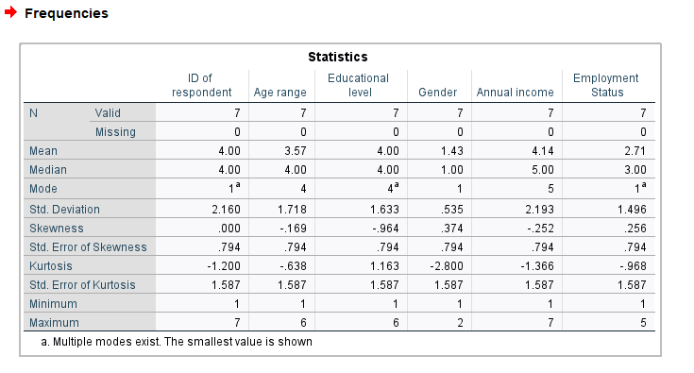

Table : Demographic descriptive results

The analysis results in Table 4 show that the average annual income for each respondent is 5 which means that many earned a range between $100,000 to $150000. There is a standard deviation of $2.193, which means that there is a small range of incomes among the respondents. The minimum respondent is 1 and the maximum respondent is 7.

The mode of the income distribution is 5, which means that most respondents earn between $100000 and $150000 per year. The median income is also 5, which means that half of the respondents earn more than $100000 per year and half earn less. The skewness of the income distribution is negative, which means that the distribution is skewed to the left. This means that there are more respondents with lower incomes than there are respondents with higher incomes.

The kurtosis of the income distribution is positive, which means that the distribution is peaked. This implies that there are a few respondents with very high incomes, which is skewing the distribution to the right.

**Descriptive Analysis of the Qualitative Data**

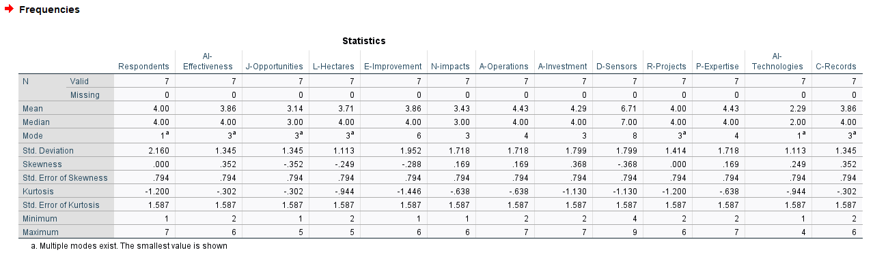

Figure 1: descriptive analysis on qualitative data

**Efficacy of artificial intelligence (AI) in lowering resource usage**: Respondents gave AI an average score of 3.9 out of 5, indicating that the majority of them agreed that it had a significant impact on the amount of resources needed in agriculture. This shows that artificial intelligence (AI) has the potential to drastically cut the amount of water, energy, and land consumed in agriculture.

**Efficiency benefit:** Respondents gave a mean score of 4.4 out of 5 for the efficiency gain brought about by the application of AI in agricultural operations. This shows that AI can aid farmers in increasing food production while using less resources.

**Increased employment opportunities**: According to the respondents, AI technologies have generated an average of 3,000 new positions in the agricultural industry. Although this is a sizable number, it is crucial to remember that it represents a small portion of all the jobs in the agricultural sector.

**Impacts on the environment:** People who responded expressed some concern about AI's possible adverse effects on the environment in agriculture. The most common concern was the use of AI-powered drones for pesticide spraying. Drones can be more efficient than traditional methods of pesticide spraying, but they also have the potential to drift and pollute water bodies. The responses from the respondents showed that the rate was ranging between 21% to 30%.

The graph in Fig 2 below shows how the respondents reacted to the interview questions that were presented to them.

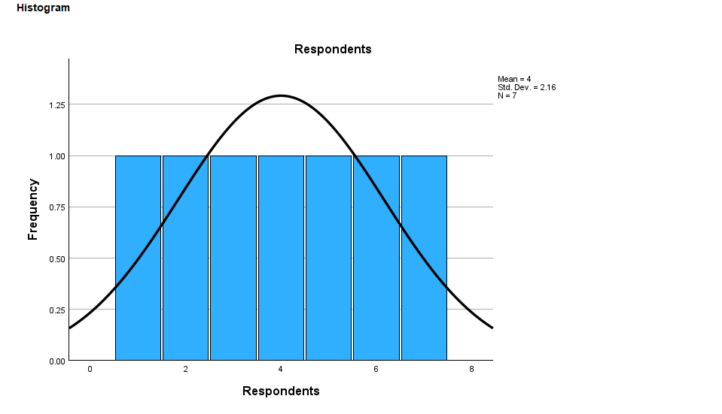

Figure 2: Respondents

It is clear from the above data that all the respondents provided essential data and reacted positively and were able to provide desirable, ideal information regarding the subject matter.

Figure 3 below show the interviewees’ response on the effectiveness of AI on agriculture.

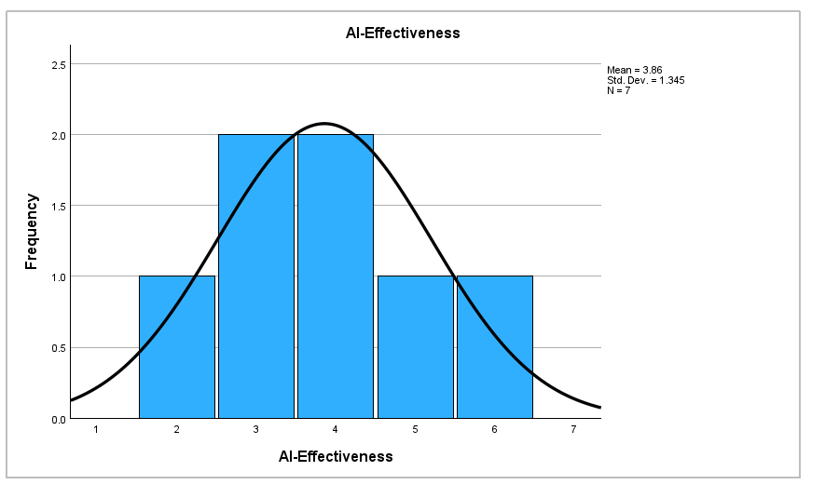

Figure 3:AI effectiveness on agriculture

The result in Fig 3 indicates that most respondents agreed that the adoption of AI was much effective and has helped to reduce resources usage in agriculture.

Based on the findings, the implementation of AI in agriculture has direct correlation with creation of job opportunities as shown in Fig 4 below.

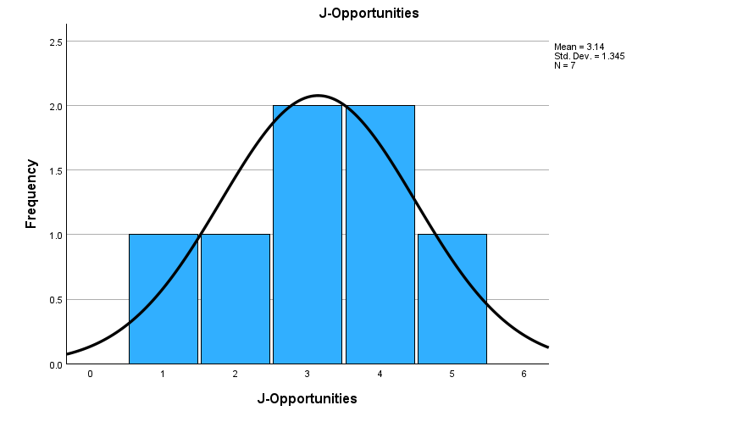

Figure 4: Job opportunities

As shown in Fig 8, the implementation of AI in agricultural sectors has led to high creation of job opportunities and still there is hope that more job creation is to be seen in future if more organization still adopts the use of AI for production.

AI adoption greatly impacts the quantity and size of land used in hectors as shown in figure 5 below.

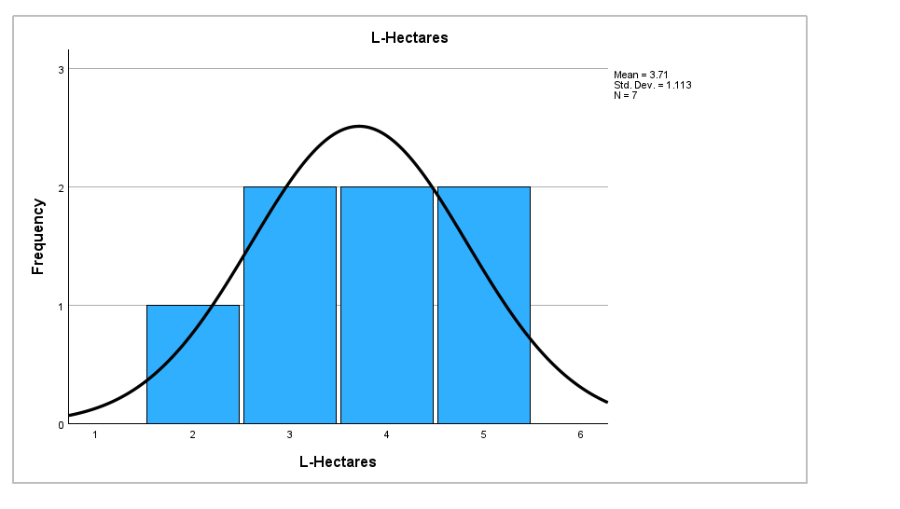

Figure 5: Land in hectares

The analysis of the responses received from the respondents as shown in Figure 9 indicates that the adoption of AI in agricultural sector has led to high usage of hectares of land, an average of 50000 to 60000 hectares has been put into use. The graph (Fig 5) shows a positive standard deviation, which indicates a progress increase in the hectares of land used after the adoption of AI in agricultural sector.

AI has direct impact on the efficiency on agricultural settings as presented in Figure 6 below.

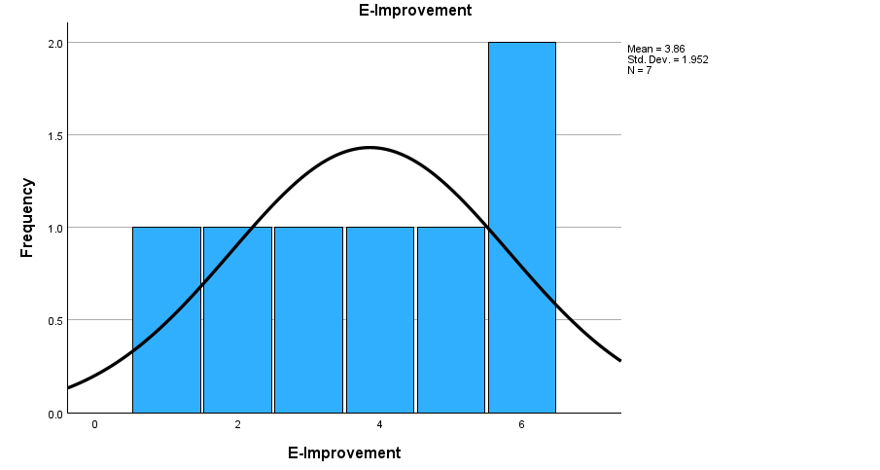

Figure 6: Efficiency improvement

In the above graph in Figure 6, the mean was 3.86, which empirically indicates that there was average improvement in the efficiency achieved through the use of AI in agricultural operations.

Regarding environmental impacts, AI adoption in agriculture presents some negative impacts as shown from findings in Fig 7 below.

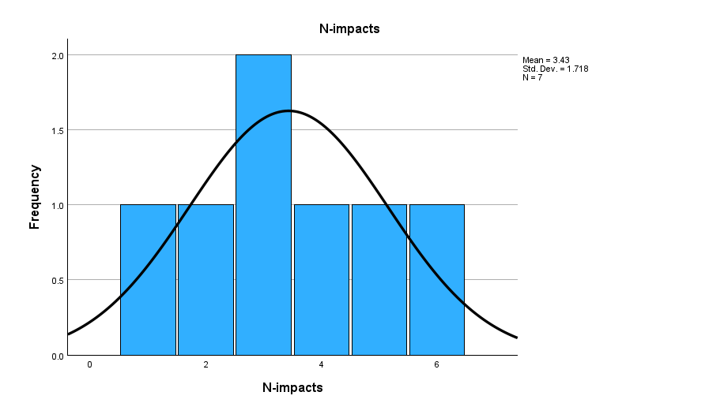

Figure 7: Negative Environmental Impacts

The graph in Figure 7 above indicates that the adoption of AI in agriculture has resulted to some negative environment impacts. Some of the identified negative impacts were water, soil and air pollutions, others also claimed that this has decreased the employment opportunity rates on manual labour.

Figure 8 below presents the impacts of AI on agricultural production.

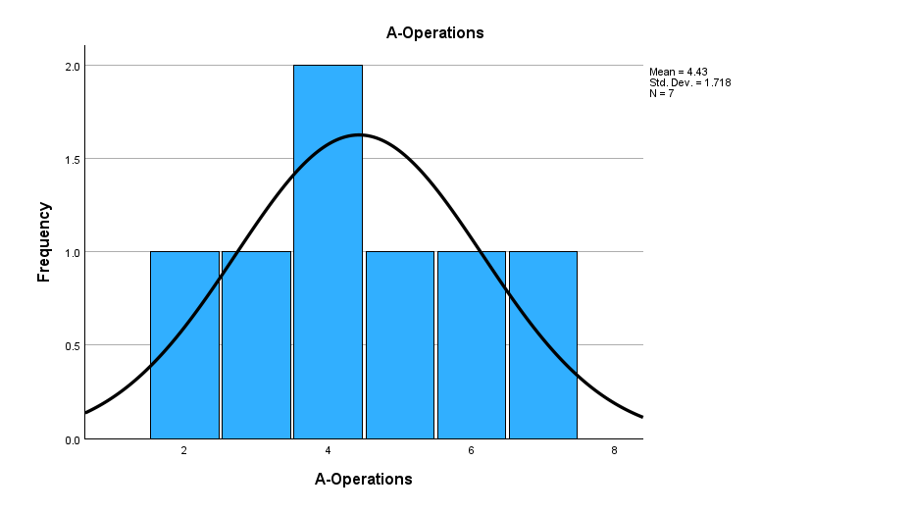

Figure 8: A- Operations

From the above graph in Figure 8, there is a positive standard deviation and a mean of 4.4, which clearly indicates that many farmers have successfully implemented AI technologies and in so doing, the sustainability of their production is greatly enhanced.

AI adoption in agriculture has a significant return on investment as shown in Figure 9 below.

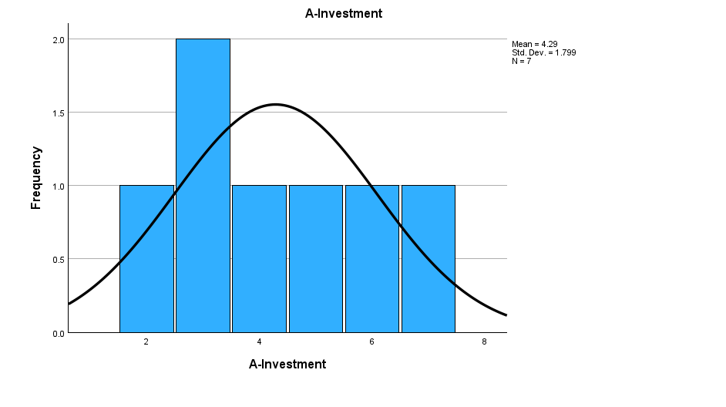

Figure 9: A- Investments

The histogram in Figure 9 above shows a mean average of 4.3 and a positive standard deviation. These findings suggest that high average return on investment have been observed by organization that implement AI technologies in their agricultural production processes.

The findings, as shown in Figure 10 below have also shown that more research and development projects are underway regarding AI adoption in agriculture.

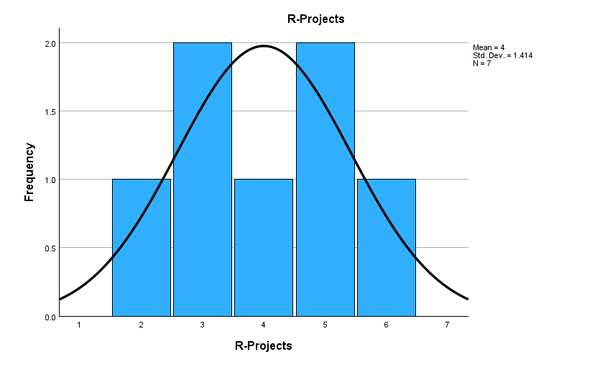

Figure 10: Ongoing AI-Agriculture Research Projects

As shown in Figure 10, some of the respondents reported that there were some research projects which were underway while some denied that they could not reveal this to private researcher. The analysis still shows that the mean was 4 out of 7, this indicates that most respondents were able to give positive feedback on this question on those projects that are exploring the use of AI in agriculture.

The graph in Figure 11 below indicates that percentage of the future development according to the respondents’ expertise was 4.5 out of 5,

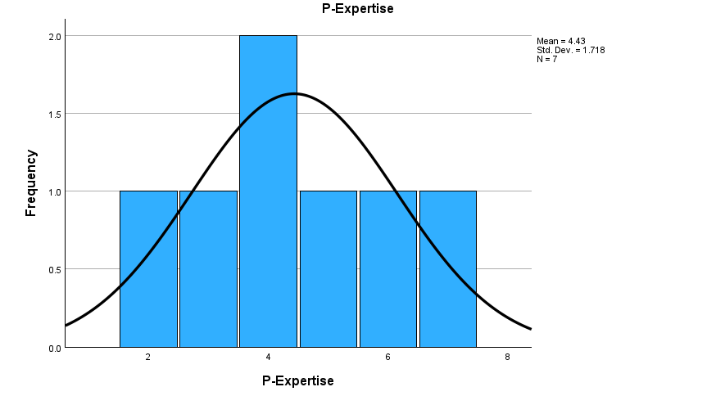

Figure 11: Personal expertise

The findings shown in Figure 11 proves that AI impacts a lot of changes as well as developments in future sustainability in agriculture. According to this finding, AI adoption in agriculture is an ideal and desirable pursuit that the agriculture sector should entirely embrace in the current dynamic, technologically-growing world.

As shown in Figure 12 below, after the analysis of the results given by various respondents, it is clear that the mean was 3.9 out of 5. This shows that many agreed that there are so many data points as well as records collected and analyzed by AI systems in agriculture. Despite of this, some were still not fully aware of the same

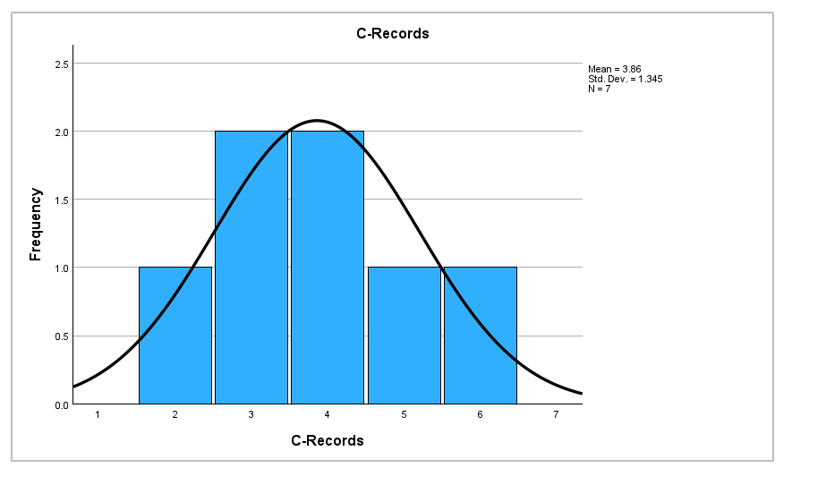

Figure 12: Collected records

## Positioning of the findings

Artificial Intelligence (AI) enhances operational sustainability in agriculture by optimizing resource usage through real-time data analysis, minimizing waste of water, fertilizers, and pesticides. It makes operations effective by automating tasks like crop scouting and pest control, leading to increased yields and reduced environmental impact. AI-driven monitoring aids in timely disease and pest interventions, reducing food waste and enhancing climate-resilient practices. Through these mechanisms, AI contributes to resource reduction, increased productivity, and improved sustainability in agricultural operations, ensuring responsible and efficient practices for a more resilient future.

## Scientific contributions

Incorporating AI in agriculture leads to profound scientific advancements. The fusion of AI's analytical power with agriculture's complex systems fuels innovation. As AI optimizes resource allocation, it propels sustainable practices by minimizing waste and environmental impact. Furthermore, AI aids in decision-making, enabling precision agriculture and yield enhancement. This symbiosis elevates the field, creating a dynamic bridge between technology and ecology. The theory that emerges underscores the transformative potential of AI in shaping agriculture's future, fostering efficiency, sustainability, and productivity for a burgeoning global population and a changing climate.

## Practical contributions

The insights gathered from various stakeholders' experiences with AI in agriculture offer valuable practical contributions. Firstly, policymakers can devise supportive frameworks that facilitate AI integration, considering subsidies and technical training to alleviate adoption barriers. Guidelines could emphasize the importance of simplifying AI for farmers and addressing data privacy concerns. For farmers, advice could focus on selecting AI solutions aligned with their specific needs, highlighting benefits like reduced costs, improved efficiency, and increased yields. Encouraging collaboration and data sharing between startups, institutions, and farmers could lead to a more integrated AI ecosystem. Consumers could benefit from awareness campaigns showcasing AI's impact on sustainable food production, influencing purchasing behaviors. Overall, practical contributions stem from tailored advice, strategic guidelines, and informed policy recommendations that collectively steer AI towards harmonizing agricultural sustainability.

## Research limitations

* Limited Scope and Generalizability: The research only covered a sample from seven respondents due to limited time, this was a very small scope.
* Sample Bias: The interview responses and insights collected from a select group of respondents does not represent the entire spectrum of stakeholders in agriculture.
* Self-Reported Data: The insights provided by respondents are based on their perceptions and self-reported experiences with AI in agriculture.
* Limited Data Sources: The information presented is based on the content provided in the initial inquiry. Additional sources of information, data, or perspectives that could provide a more comprehensive view was not considered.
* Long-Term Effects: The research largely focuses on the current state and short-term impacts of AI in agriculture. The long-term effects, both positive and negative, are not fully explored, leaving a gap in understanding the sustainability and lasting implications of AI integration.
* Harsh conditions: Some respondents were too harsh and reluctant to answer the interview questions

# Conclusion

From the findings, the incorporation of AI in the agriculture sector has enhanced the sector’s operation productivity, efficacy, and sustainability at large. The interviewees report that artificial intelligence has resulted into betterment of the core aspects of the agriculture sector and has a potential of proceeding on the same trajectory in years to come thus advancing the industry in general. The incorporation of AI in agriculture has led to a desirable redefinition of the sector’s core operations as it has stimulated operational automation of the majority of redundant activities. Activities such as crop inspection, seeding, and pest management and control are being accomplished accurately by AI. By having automated systems in the industry, the producers economically and efficiently make use of the limited available resources including land, labor, and capital, all of which are the main costs of production. In so doing, AI inevitably enhances productivity in the agriculture sector thus allowing the producers to focus on other essential aspects of agri-business including activities such as sales and promotion/marketing.

The influence of AI also extends to the streamlining of activities including agricultural seeding and irrigation, which boosts the economical utilisation of resources and lowers costs. By using AI to assess data and make decisions in real time, farmers can tailor their farming methods to the needs of particular fields which enables the producers to lessen the amount of essential resources—such as water and fertilizers—that wasted and misused. Precision agriculture mitigates operational costs and aids in the development of more sustainable farming practises by minimising the negative effects of resource use on the environment as a whole.

Moreover, the results show that AI plays a significant part in the process of arriving at better selections. Farmers are now able to make more educated decisions on crop planting, irrigation, and pest control because to the power of AI to process massive volumes of data and generate insights in real time. This type of decision-making, which is driven by data, results in increased yields and lower costs for farmers. This is because farmers are able to focus their interventions more precisely, which eliminates the necessity of applying an excessive amount of pesticides or fertilisers. Consequently, this leads to a more effective utilisation of inputs, a diminished influence on the surrounding environment, and an increase in total production.

Another key advantage connected with the adoption of AI in agriculture is the reduction in associated expenses and costs. About half of the respondents acknowledged that the potential of AI to automate processes and optimise operations led to a reduction in the costs associated with running their businesses. Farmers will be able to reduce their spending on labour, inputs such as water and fertilisers, and total operational costs as AI continues to improve existing processes. This reduction in costs is beneficial not only to individual farmers but also makes a contribution to the long-term economic viability of the agricultural sector as a whole. In addition, the money saved can be put towards the development of new technologies or the promotion of sustainable practises, so starting a virtuous cycle of never-ending progress. The conversation sheds insight on the role artificial intelligence plays in improved crop production. Through the automation of labor-intensive jobs, artificial intelligence gives farmers the ability to devote more time to activities that directly influence crop production, which eventually results in increased yields. An optimistic future lies ahead for the agriculture sector as a result of the many positive effects that may be reaped through the application of AI. These effects include improved productivity in addition to decreased expenses.

The ongoing growth of AI in agriculture, on the other hand, is not progressing without its fair share of obstacles. In the interview, it is acknowledged that there may be possible roadblocks, such as the high cost of AI technologies and the requirement for farmers to have technical competence. In spite of these challenges, the results of the interviews highlight the potential for AI to play an increasingly crucial role in the agricultural industry. There is a strong motivation for further exploration and integration of AI technology, given the benefits it brings in terms of efficiency, cost reduction, and improvement in yield. The impact that AI will have on agriculture will, in essence, rewrite the rules that have always been followed, thereby paving the way for a more environmentally friendly and fruitful future. The good influence that was shown throughout the interviews reveals that the journey of AI inside agriculture has only just begun, despite the fact that there are still challenges that exist. In the coming years, artificial intelligence is set to take centre stage in meeting the evolving needs of modern agriculture, assuring food security, resource efficiency, and environmental sustainability. This will be made possible by the rapid advancement of technology and the growing awareness of its potential.

# Bibliography

Abioye, Sofiat O, Oyedele, Lukumon O, Akanbi, L., Ajayi, A., Manuel, J., Bilal, M., Akinade, Olugbenga O, & Ahmed, A. (2021). Artificial intelligence in the construction industry: A review of present status, opportunities and future challenges. *Journal of Building Engineering*, *44*, 103299. <https://doi.org/10.1016/j.jobe.2021.103299>

Almalki, S. (2016). Integrating Quantitative and Qualitative Data in Mixed Methods Research--Challenges and Benefits. *Journal of Education and Learning*, *5*(3), 288–296. <https://eric.ed.gov/?id=EJ1110464>

Altman, A., & Mesoudi, A. (2019). Understanding agriculture within the frameworks of cumulative cultural evolution, gene-culture co-evolution, and cultural niche construction. *Human Ecology*, *47*, 483–497. <https://doi.org/10.1007/s10745-019-00090-y>

Araújo, S. O., Peres, R. S., Barata, J., Lidon, F., & Ramalho, J. C. (2021). Characterising the agriculture 4.0 Landscape—Emerging trends, challenges and opportunities. *Agronomy*, *11*, 667. <https://doi.org/10.3390/agronomy11040667>

Awasthi, M. K., Sarsaiya, S., Wainaina, S., Rajendran, K., Kumar, S., Quan, W., Duan, Y., Awasthi, S. K., Chen, H., Pandey, A., Zhang, Z., Jain, A., & Taherzadeh, M. J. (2019). A critical review of organic manure biorefinery models toward sustainable circular bioeconomy: Technological challenges, advancements, innovations, and future perspectives. *Renewable and Sustainable Energy Reviews*, *111*, 115–131. <https://doi.org/10.1016/j.rser.2019.05.017>

Aydoğan, B., & Vardar, G. (2019). Evaluating the role of renewable energy, economic growth and agriculture on CO2 emission in E7 countries. *International Journal of Sustainable Energy*, 1–14. <https://doi.org/10.1080/14786451.2019.1686380>

Ayed, B., & Hanana, M. (2021, April). *Artificial intelligence to improve the food and agriculture sector*. Journal of Food Quality. <https://www.hindawi.com/journals/jfq/2021/5584754/>

Azunre, Gideon Abagna, Amponsah, O., Peprah, C., Takyi, S. A., & Braimah, I. (2019). A review of the role of urban agriculture in the sustainable city discourse. *Cities*, *93*, 104–119. <https://doi.org/10.1016/j.cities.2019.04.006>

Barja-Martinez, S., Mònica Aragüés-Peñalba, Íngrid Munné-Collado, Pau Lloret-Gallego, Sumper, A., & Villafafila-Robles, R. (2021). Artificial intelligence techniques for enabling Big Data services in distribution networks: A review. *Renewable & Sustainable Energy Reviews*, *150*, 111459–111459. <https://doi.org/10.1016/j.rser.2021.111459>

Basso, B., & Antle, J. (2020). Digital agriculture to design sustainable agricultural systems. *Nature Sustainability*, *3*, 254–256. <https://doi.org/10.1038/s41893-020-0510-0>

Boettger, R. K., & Palmer, L. A. (2010). Quantitative Content Analysis: Its Use in Technical Communication. *IEEE Transactions on Professional Communication*, *53*(4), 346–357. <https://doi.org/10.1109/tpc.2010.2077450>

Bolarinwa, O. A. (2015). Principles and methods of validity and reliability testing of questionnaires used in social and health science researches. *Nigerian Postgraduate Medical Journal*, *22*(4), 195–201. <https://doi.org/10.4103/1117-1936.173959>

Bonnedahl, K. J., Heikkurinen, P., & Paavola, J. (2022). Strongly sustainable development goals: Overcoming distances constraining responsible action. *Environmental Science & Policy*, *129*, 150–158. <https://doi.org/10.1016/j.envsci.2022.01.004>

Braun, V., & Clarke, V. (2019). To saturate or not to saturate? Questioning data saturation as a useful concept for thematic analysis and sample-size rationales. *Qualitative Research in Sport, Exercise and Health*, *13*(2), 1–16. <https://doi.org/10.1080/2159676x.2019.1704846>

Dastrup, A. (2019, May). *6.2 types of agriculture*. Pressbooks.pub. <https://pressbooks.pub/humangeography/chapter/6-2/#:~:text=Today%2C%20there%20are%20two%20divisions>

Elahi, E., Khalid, Z., & Zhang, Z. (2022). Understanding farmers’ intention and willingness to install renewable energy technology: A solution to reduce the environmental emissions of agriculture. *Applied Energy*, *309*, 118459. <https://doi.org/10.1016/j.apenergy.2021.118459>

Elo, S., & Kyngäs, H. (2008). The qualitative content analysis process. *Journal of Advanced Nursing*, *62*(1), 107–115. <https://doi.org/10.1111/j.1365-2648.2007.04569.x>

Fan, W., & Yan, Z. (2010). Factors affecting response rates of the web survey: A systematic review. *Computers in Human Behavior*, *26*(2), 132–139. https://doi.org/10.1016/j.chb.2009.10.015

Fielding, N. G. (2012). Triangulation and Mixed Methods Designs. *Journal of Mixed Methods Research*, *6*(2), 124–136. <https://doi.org/10.1177/1558689812437101>

Fukase, E., & Martin, W. (2020). Economic growth, convergence, and world food demand and supply. *World Development*, *132*, 104954. <https://doi.org/10.1016/j.worlddev.2020.104954>

Ghadermarzi, H., Ataei, P., Karimi, H., & Safaei, Safe Allah. (2020). Assessment of social sustainability components in agriculture sector of Iran using a systemic approach. *Paddy and Water Environment*, *18*, 547–559. <https://doi.org/10.1007/s10333-020-00800-z>

Goubran, S., Masson, T., & Caycedo, M. (2018). Evolutions in sustainability and sustainable real estate. *Sustainable Real Estate*, 11–31. <https://doi.org/10.1007/978-3-319-94565-1_3>

Halbrendt, J., Gray, S. A., Crow, S., Radovich, T., Kimura, A. H., & Tamang, B. B. (2014). Differences in farmer and expert beliefs and the perceived impacts of conservation agriculture. *Global Environmental Change*, *28*, 50–62. <https://doi.org/10.1016/j.gloenvcha.2014.05.001>

Hamilton, A. B., & Finley, E. P. (2019). Qualitative methods in implementation research: An introduction. *Psychiatry Research*, *280*(5), 112516. <https://doi.org/10.1016/j.psychres.2019.112516>

Han, C. (2015). How to Do Critical Discourse Analysis: A Multimodal Introduction. *Australian Journal of Linguistics*, *35*(4), 415–418. <https://doi.org/10.1080/07268602.2015.1033673>

Himeur, Y., Elnour, M., Fadli, F., Meskin, N., Petri, I., Rezgui, Y., Bensaali, F., & Amira, A. (2022). AI-big data analytics for building automation and management systems: a survey, actual challenges and future perspectives. *Artificial Intelligence Review*. <https://doi.org/10.1007/s10462-022-10286-2>

Hussein, A. (2009). The use of Triangulation in Social Sciences Research. *Journal of Comparative Social Work*, *4*(1), 106–117. <https://doi.org/10.31265/jcsw.v4i1.48>

IPBES. (2019). *Global assessment report on biodiversity and ecosystem services | IPBES*. Ipbes.net. <https://www.ipbes.net/global-assessment>

IRENA. (2019). *International renewable energy agency (IRENA)*. Irena.org. <https://www.irena.org/>

Jackson, D., Power, T., & Walthall, H. (2023). Navigating the Maze of Research: Enhancing Nursing and Midwifery Practice. In *Google Books*. Elsevier Health Sciences. <https://books.google.co.ke/books?hl=en&lr=&id=TbSvEAAAQBAJ&oi=fnd&pg=PA125&dq=the+mixed-methods+approach+allowed+the+researcher+to+collect+data+from+a+wider+range+of+respondents&ots=E0Wp5GyzhZ&sig=-qkJWyFwLw3Liveiht8conJ7aAc&redir_esc=y#v=onepage&q&f=false>

Janker, J., Mann, S., & Rist, S. (2019). Social sustainability in agriculture – A system-based framework. *Journal of Rural Studies*, *65*, 32–42. <https://doi.org/10.1016/j.jrurstud.2018.12.010>

Kakadellis, S., & Harris, Z. M. (2020). Don’t scrap the waste: The need for broader system boundaries in bioplastic food packaging life-cycle assessment – A critical review. *Journal of Cleaner Production*, *274*, 122831. <https://doi.org/10.1016/j.jclepro.2020.122831>

Klerkx, L. W. A, van, M. B., & Leeuwis, C. (2012). Evolution of systems approaches to agricultural innovation: concepts, analysis and interventions. *Farming Systems Research into the 21st Century: The New Dynamic*, 457–483. <https://doi.org/10.1007/978-94-007-4503-2_20>

Kose, U., Prasath, V. B. S., Mondal, M. R. H., Podder, P., & Bharati, S. (2022). *Artificial intelligence and smart agriculture technology*. Auerbach.

Lajoie-O’Malley, A., Bronson, K., van, & Klerkx, L. (2020). The future(s) of digital agriculture and sustainable food systems: An analysis of high-level policy documents. *Ecosystem Services*, *45*, 101183. <https://doi.org/10.1016/j.ecoser.2020.101183>

Lewis, S. C., Zamith, R., & Hermida, A. (2013). Content Analysis in an Era of Big Data: A Hybrid Approach to Computational and Manual Methods. *Journal of Broadcasting & Electronic Media*, *57*(1), 34–52. <https://doi.org/10.1080/08838151.2012.761702>

Liu, Y., Ma, X., Shu, L., Hancke, Gerhard Petrus, & Abu-Mahfouz, Adnan M. (2021). From industry 4.0 to agriculture 4.0: Current status, enabling technologies, and research challenges. *IEEE Transactions on Industrial Informatics*, *17*, 4322–4334. <https://doi.org/10.1109/tii.2020.3003910>

LTd, I. A. P. (2023, March 30). *Sustainable Agriculture Market 2023 | Exclusive Report on the Latest Revenue and Future Scope to 2031 - InsightAce Report*. GlobeNewswire News Room. <https://www.globenewswire.com/news-release/2023/03/30/2637412/0/en/Sustainable-Agriculture-Market-2023-Exclusive-Report-on-the-Latest-Revenue-and-Future-Scope-to-2031-InsightAce-Report.html>

Lynch, J., Donnellan, T., Finn, J. A., Dillon, E., & Ryan, M. (2019). Potential development of Irish agricultural sustainability indicators for current and future policy evaluation needs. *Journal of Environmental Management*, *230*, 434–445. <https://doi.org/10.1016/j.jenvman.2018.09.070>

Mauricio, G.-P. J., Couturier, S., Figueroa, D., & Jiménez, A. D. (2021). Is rural food security primarily associated with smallholder agriculture or with commercial agriculture?: An approach to the case of Mexico using structural equation modeling. *Agricultural Systems*, *190*, 103091. <https://doi.org/10.1016/j.agsy.2021.103091>

McKim, C. A. (2017). The Value of Mixed Methods Research. *Journal of Mixed Methods Research*, *11*(2), 202–222. sagepub.

Mhlanga, D. (2021). Artificial intelligence in the industry 4.0, and its impact on poverty, innovation, infrastructure development, and the sustainable development goals: Lessons from emerging economies? *Sustainability*, *13*, 5788. <https://doi.org/10.3390/su13115788>

Mhlanga, D. (2022). Human-centered artificial intelligence: The superlative approach to achieve sustainable development goals in the fourth industrial revolution. *Sustainability*, *14*, 7804. <https://doi.org/10.3390/su14137804>

Mirabelli, G., & Solina, V. (2020). Blockchain and agricultural supply chains traceability: research trends and future challenges. *Procedia Manufacturing*, *42*, 414–421. <https://doi.org/10.1016/j.promfg.2020.02.054>

Mohammad Javad Emadi, & Rahmanian, M. (2020). *Commentary on challenges to taking a food systems approach within the food and agriculture organization (FAO)*. 19–31. <https://doi.org/10.1007/978-3-030-36762-6_2>

Mohr, S., & Kühl, R. (2021). Acceptance of artificial intelligence in German agriculture: an application of the technology acceptance model and the theory of planned behavior. *Precision Agriculture*, *2*(1). <https://doi.org/10.1007/s11119-021-09814-x>

Munawar, S., Qamar, Mustafa, G., Khan, M. S., & Joyia, Faiz Ahmad. (2020). Role of biotechnology in climate resilient agriculture. *Environment, Climate, Plant and Vegetation Growth*, 339–365. <https://doi.org/10.1007/978-3-030-49732-3_14>

N, M. N., Dixit, Y., Al-Mallahi, A., Bhullar, M. S., Upadhyay, R., & Martynenko, A. (2020). IoT, big data and artificial intelligence in agriculture and food industry. *IEEE Internet of Things Journal*, *9*, 1–1. <https://doi.org/10.1109/jiot.2020.2998584>

Nations, U. (2015). *The 17 sustainable development goals*. United Nations; United Nations. <https://sdgs.un.org/goals>

Nations, U. (2019, November). *Emissions gap report 2019*. UNEP - UN Environment Programme. <https://www.unep.org/resources/emissions-gap-report-2019>

Padilla, J. E., & Hudson, A. (2019). United Nations development programme (UNDP) perspectives on Asian Large Marine Ecosystems. *Deep Sea Research Part II: Topical Studies in Oceanography*, *163*, 127–129. <https://doi.org/10.1016/j.dsr2.2019.05.011>

Pietrosemoli, L., & Rodríguez-Monroy, C. (2019). The Venezuelan energy crisis: Renewable energies in the transition towards sustainability. *Renewable and Sustainable Energy Reviews*, *105*, 415–426. <https://doi.org/10.1016/j.rser.2019.02.014>

Polit, D. F., & Beck, C. T. (2010). Generalization in Quantitative and Qualitative Research: Myths and Strategies. *International Journal of Nursing Studies*, *47*(11), 1451–1458. <https://doi.org/10.1016/j.ijnurstu.2010.06.004>

Prishchepov, A. V., Müller, D. J., Nikolay Dronin, Ponkina, E., & R, M. D. (2019). *800 years of agricultural land-use change in asian (eastern) russia*. 67–87. <https://doi.org/10.1007/978-3-030-15927-6_6>

Ruggerio, C. A. (2021). Sustainability and sustainable development: A review of principles and definitions. *Science of the Total Environment*, *786*, 147481. <https://doi.org/10.1016/j.scitotenv.2021.147481>

Ruston, A., Shortall, O., Green, M., Brennan, M., Wapenaar, W., & Kaler, J. (2016). Challenges facing the farm animal veterinary profession in England: A qualitative study of veterinarians’ perceptions and responses. *Preventive Veterinary Medicine*, *127*(3), 84–93. <https://doi.org/10.1016/j.prevetmed.2016.03.008>

Sachithra, V., & Subhashini, L. D. C. S. (2023). How artificial intelligence uses to achieve the agriculture sustainability: Systematic review. *Artificial Intelligence in Agriculture*. <https://doi.org/10.1016/j.aiia.2023.04.002>

Schöning, J., & Richter, M. L. (2021, October 1). *AI-Based Crop Rotation for Sustainable Agriculture Worldwide*. IEEE Xplore. https://doi.org/10.1109/GHTC53159.2021.9612460

Sommerville, A. (2022, January). *What is the workforce capability framework?* Acorn LMS. <https://acornlms.com/resources/capability-framework#:~:text=A%20capability%20framework%20outlines%20the%20skills%2C%20behaviours%20and%20knowledge%20required>

Terrell, S. R. (2012). Mixed-Methods Research Methodologies. *Qualitative Report*, *17*(1), 254–280. <https://eric.ed.gov/?id=EJ973044>

The World Bank. (2018). *Employment in agriculture (% of total employment) (modeled ILO estimate) | data*. Worldbank.org. <https://data.worldbank.org/indicator/SL.AGR.EMPL.ZS>

Tudi, M., Ruan, D., Wang, L., Lyu, J., Sadler, R., Connell, D., Chu, C., & Phung, D. T. (2021). Agriculture development, pesticide application and its impact on the environment. *International Journal of Environmental Research and Public Health*, *18*. <https://doi.org/10.3390/ijerph18031112>

United Nations. (2017). *World population projected to reach 9.8 billion in 2050, and 11.2 billion in 2100*. United Nations. <https://www.un.org/en/desa/world-population-projected-reach-98-billion-2050-and-112-billion-2100#:~:text=COVID%2D19->

Vaismoradi, M., Jones, J., Turunen, H., & Snelgrove, S. (2016). Theme Development in Qualitative Content Analysis and Thematic Analysis. *Journal of Nursing Education and Practice*, *6*(5), 100–110. <https://doi.org/10.5430/jnep.v6n5p100>

Yilmaz, K. (2013). Comparison of Quantitative and Qualitative Research traditions: Epistemological, theoretical, and Methodological Differences. *European Journal of Education*, *48*(2), 311–325.

**Appendix A. Title of the Annex.**

**Interview questions**



**Qualitative interview responses**



**Quantitative and Demographic interview responses**

